



Mobile App Development 1

Study diary

by Dmitrii Bacherikov

Contents

1 Week exercises 3

1.1 Android Studio setup and Hello World 3

2 Week exercises 4

What is activity and what is the role of XML and Java files when implementing GUI? 4

3 Week exercises 6

4 Week exercises 9

4.1 Address class 9

5 Week exercises 12

5.1 App GUI with 2 screens 12

5.2 Written exercises 14

6 Week exercises 15

6.1 Fetching HTTP data and parsing JSON 15

6.2 Fetching HTTP data and parsing JSON 15

7 Week exercises 17

7.1 Synchronous device API Example – Camera HW and “torch app” 17

7.2 Asynchronous API call example (listener) – Sensor API and “Level App” 18

8 Week exercises 19

8.1 Android app permission workflow 19

8.2 Android app permission workflow 20

9 Week exercises 22

9.1 Written answers 22

9.2 Code 22

Sources used with exercises 25

**Important general note for all weekly exercises: List all external sources you’ve used to implement the task (github, tutorialspoint, other projects, network sites, blogs etc..)**

# Week exercises

## Android Studio setup and Hello World

I have installed Android Studio in MacOS (Java runtime was installed previously already).

I came across with 2 issues:

- Android Studio didn’t see my Android device connected

- Failed to install the following Android SDK packages as some licences have not been accepted.

In both cases I found solutions on StackOverflow (links are given in Sources).

Here is a screenshot of successful run:

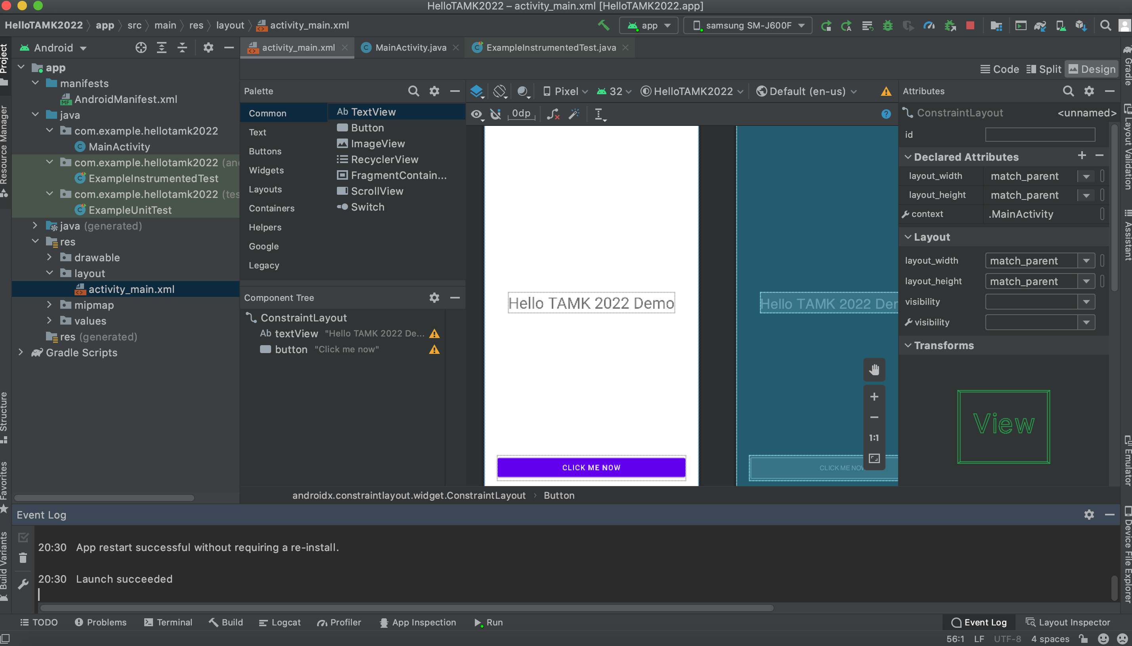

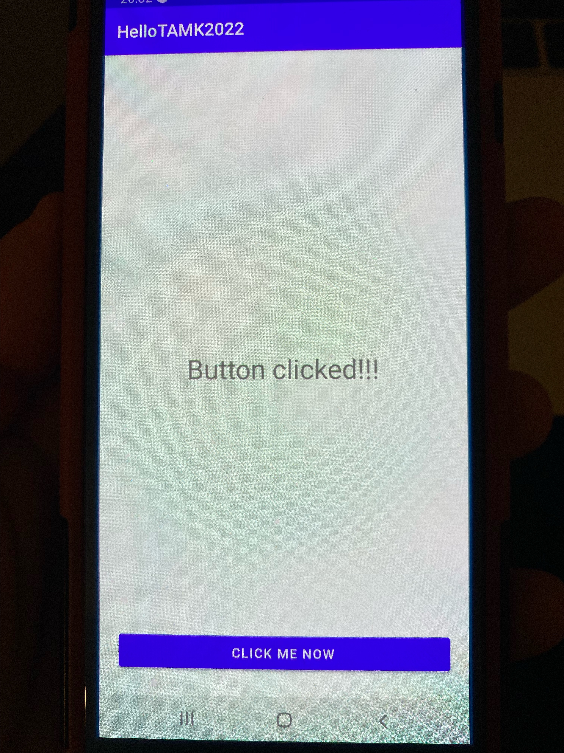

# Week exercises

## 

## What is activity and what is the role of XML and Java files when implementing GUI?

Activity is a specific screen of an applications (can be multiple activities in one applications) which consists of XML and Java files. XML is for GUI layout (design), and Java is for logic.

**What is meant by an activity lifecycle. When is activity created/closed in Android?**

An activity lifecycle is based on 7 methods: onCreate(), onStart(), onResume(), onPause(), onStop(), onRestart(), onDestroy(). Thus it can be created by onCreate() method and closed/finished by onDestroy() method.

Main activity is created when the application is launched (can be other activities which are created when the user switches to another view), and closed when the app is stopped or another activity is started.

2.2 BMI App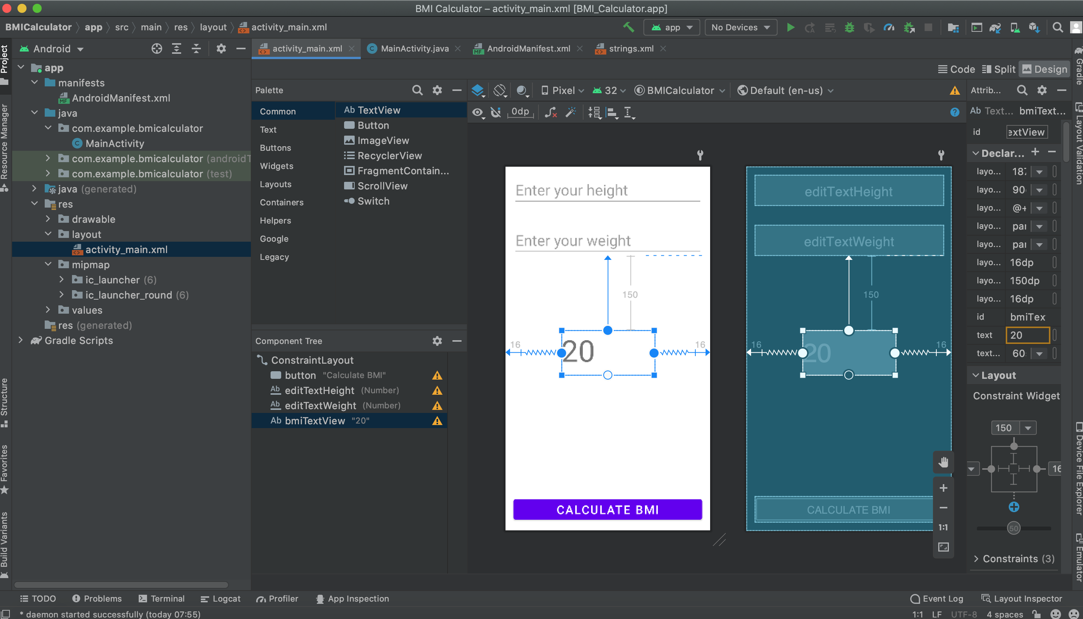

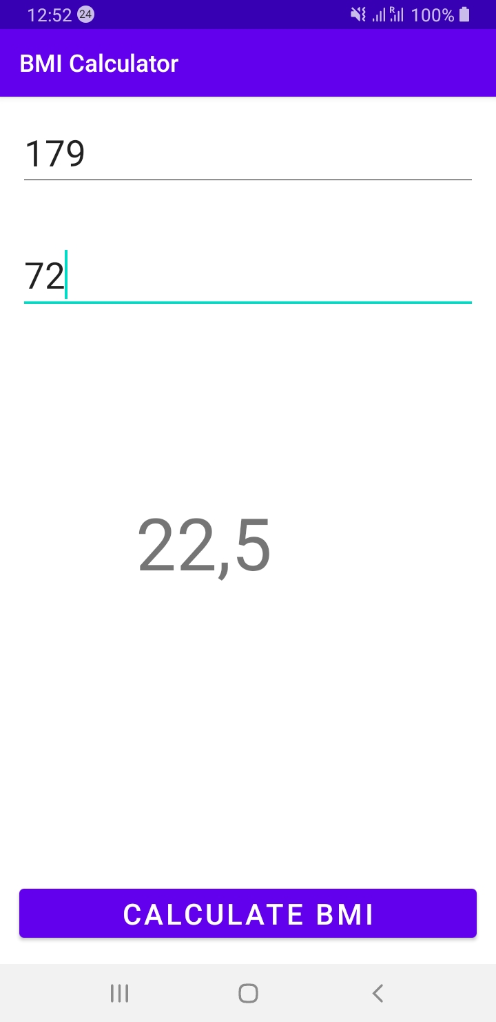

2.3 Create GUI layout with Constraint layout

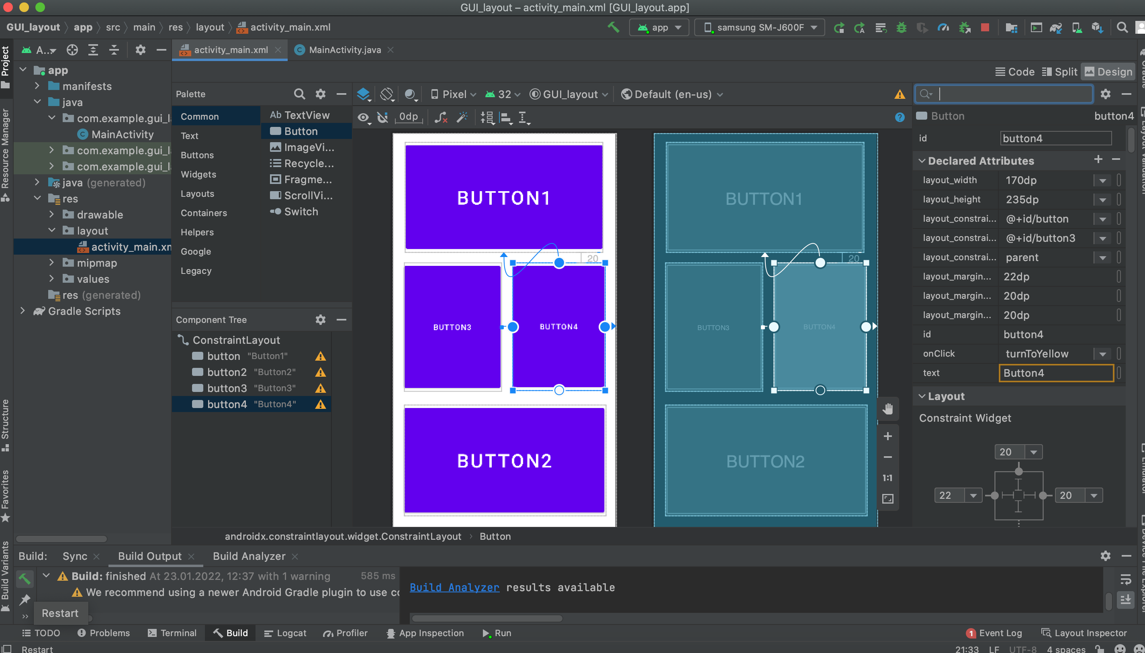

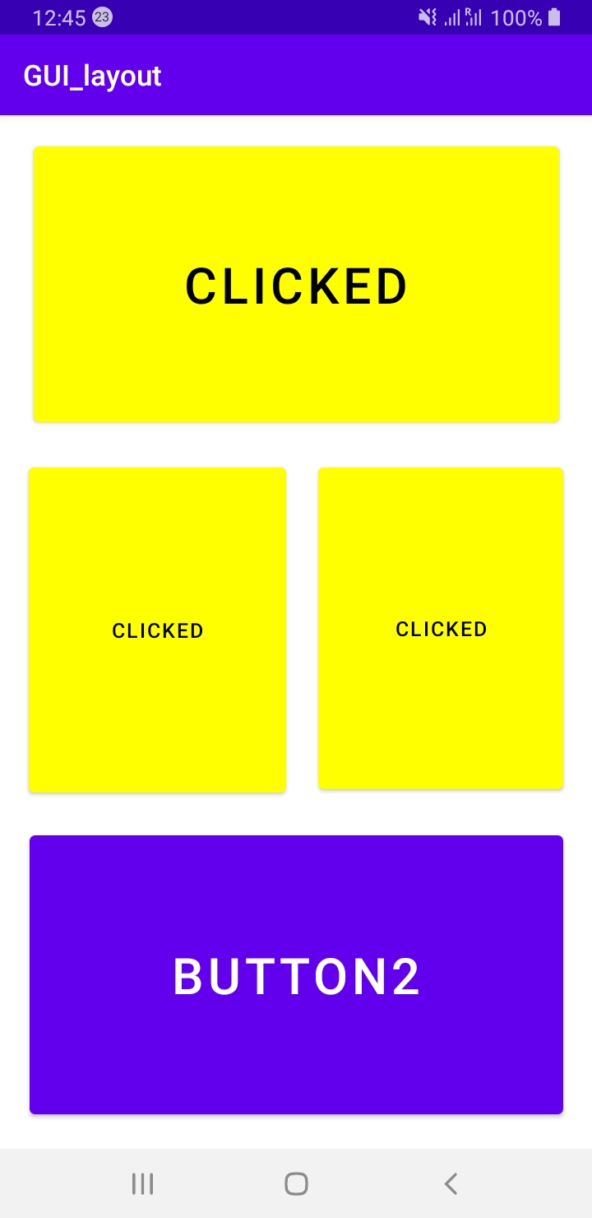

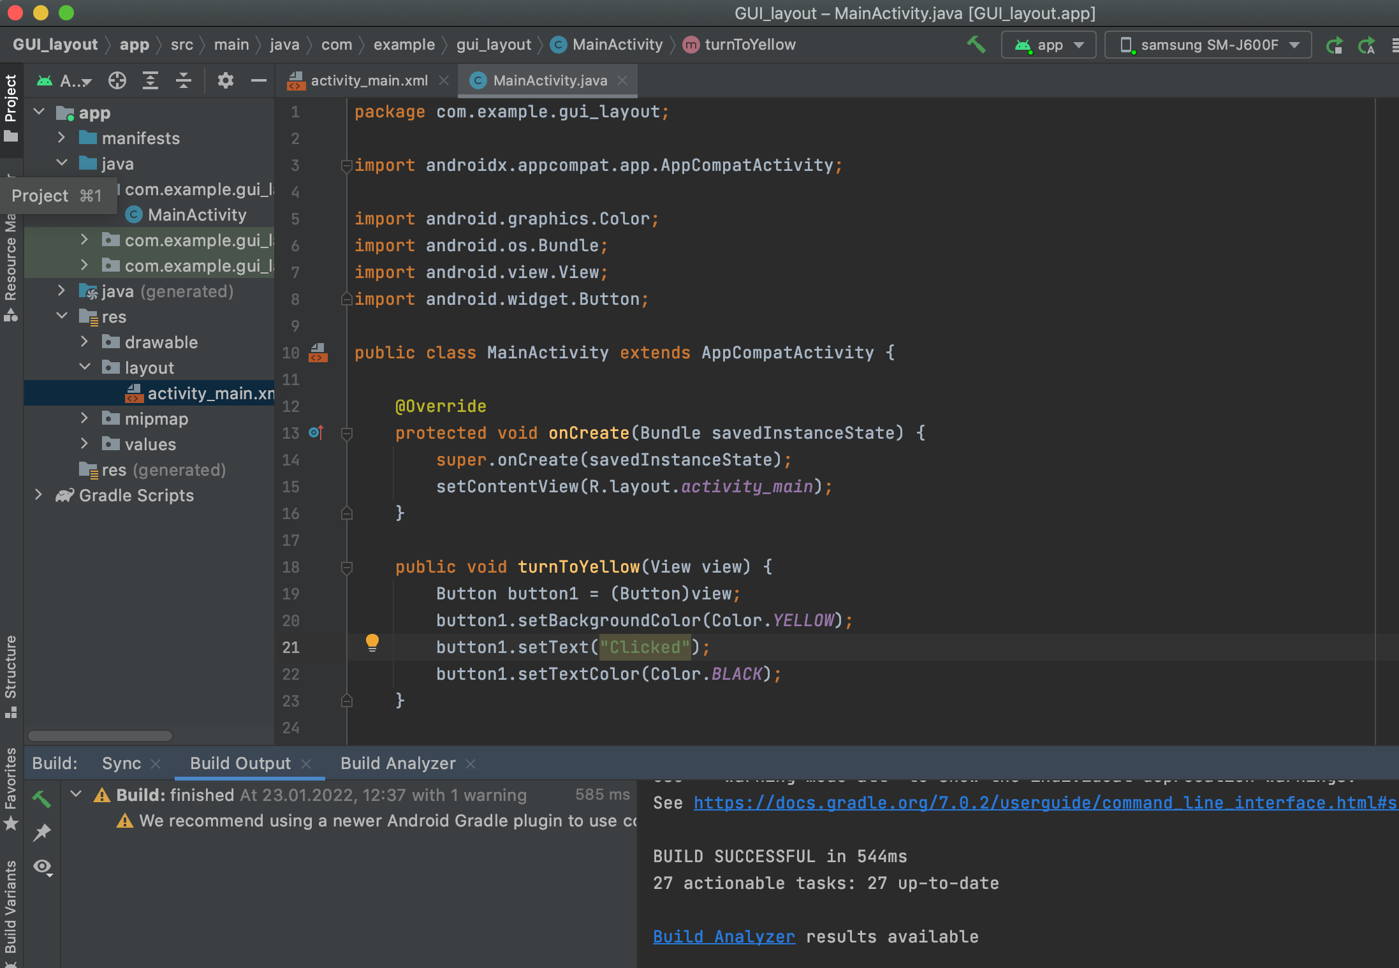

# Week exercises

## 

**What advantages you see in defining user interfaces in UI resource files (.xml) instead of coding the UI (e.g. with Java)?**

It is easier to design

* Less code is needed and no hardcode
* Easy to design layout using XML in Android Studio
* Easy to localize for different devices
* Easier to maintain
* It is faster

**In Android studio, how localization and language variants are created for an Android project?**

In the editor we add Locale/languages needed (another XML file is created), then we add translations.

**3.2**

Removed all hard coded strings and put them into strings.xml

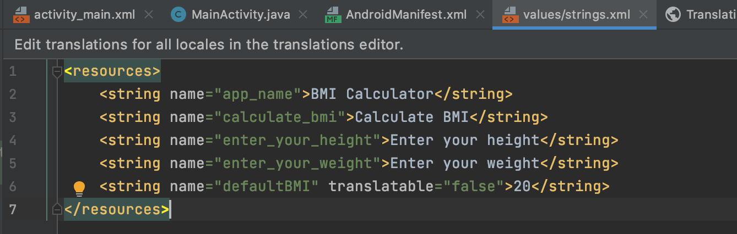

Added 2 more languages (Russian and Finnish)

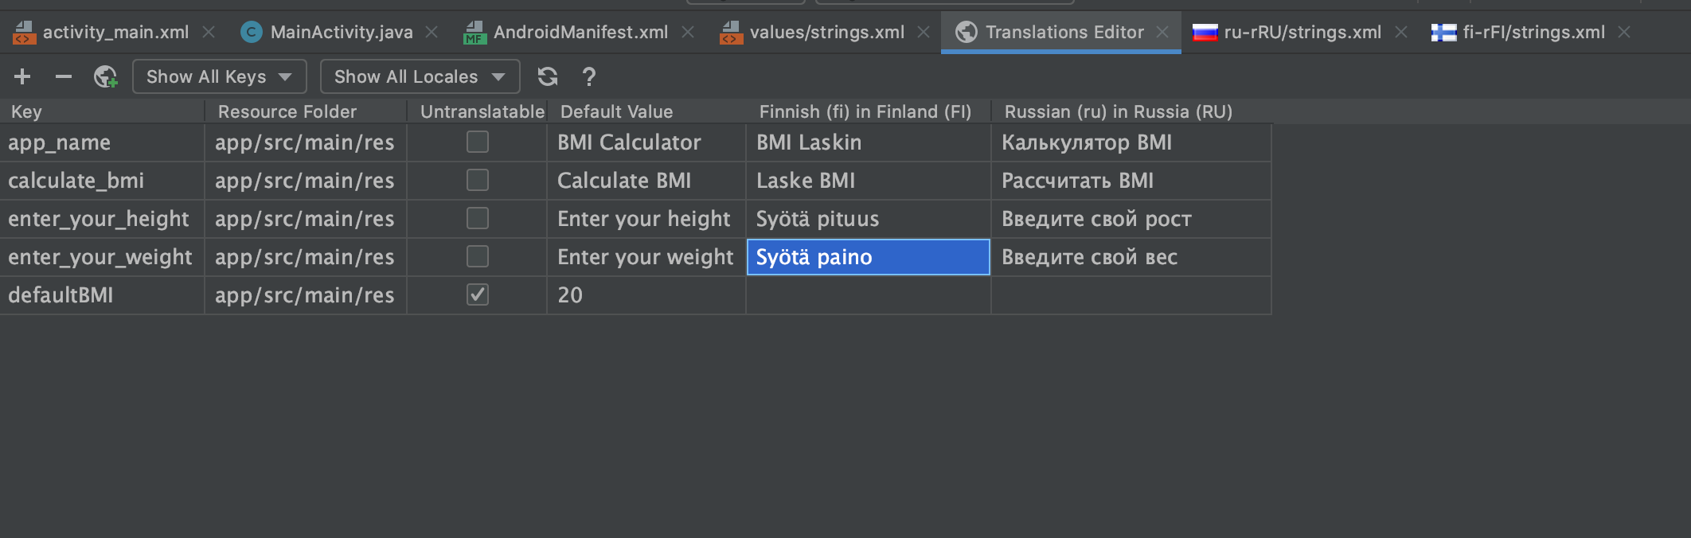

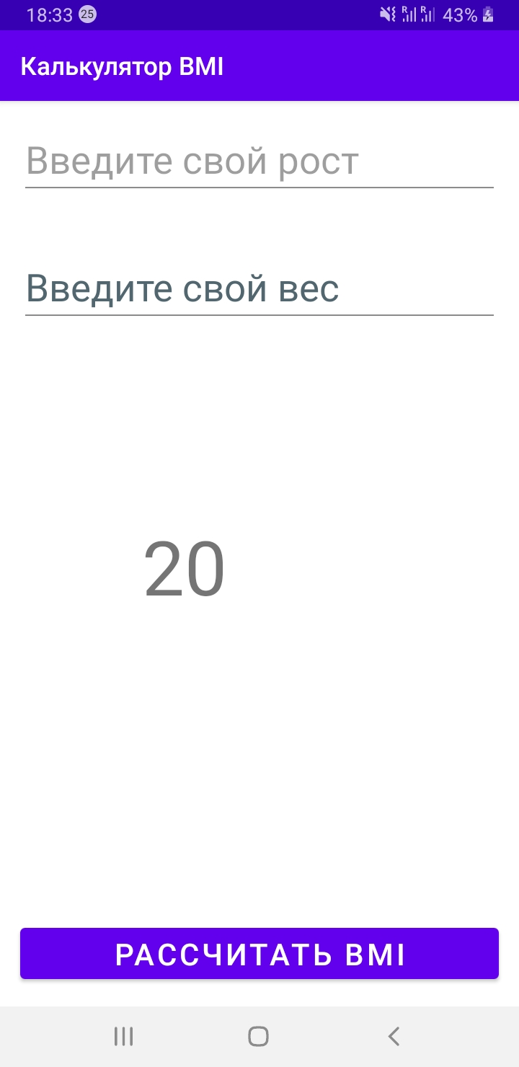

**3.3 Java app consisting of Main.java and Student.java files**

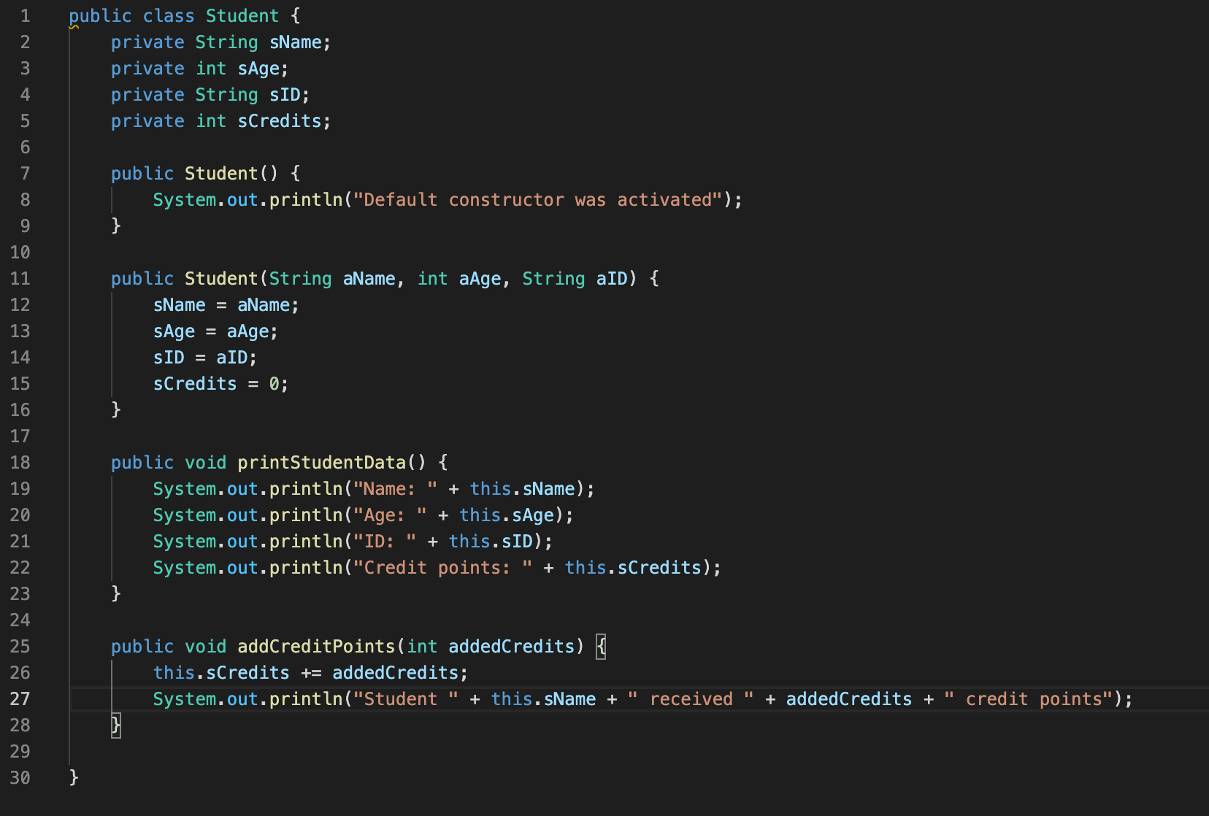

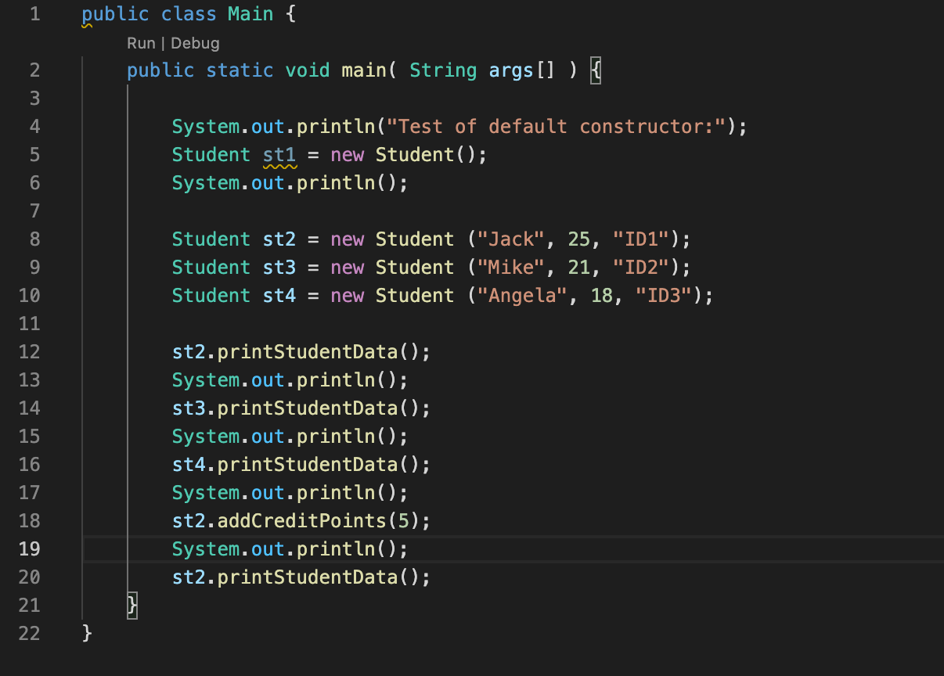

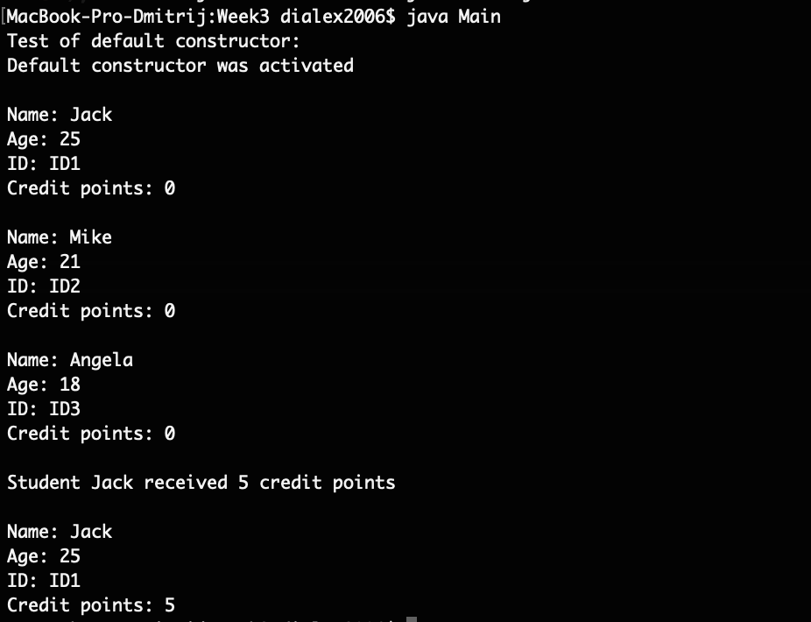

# Week exercises

## Address class

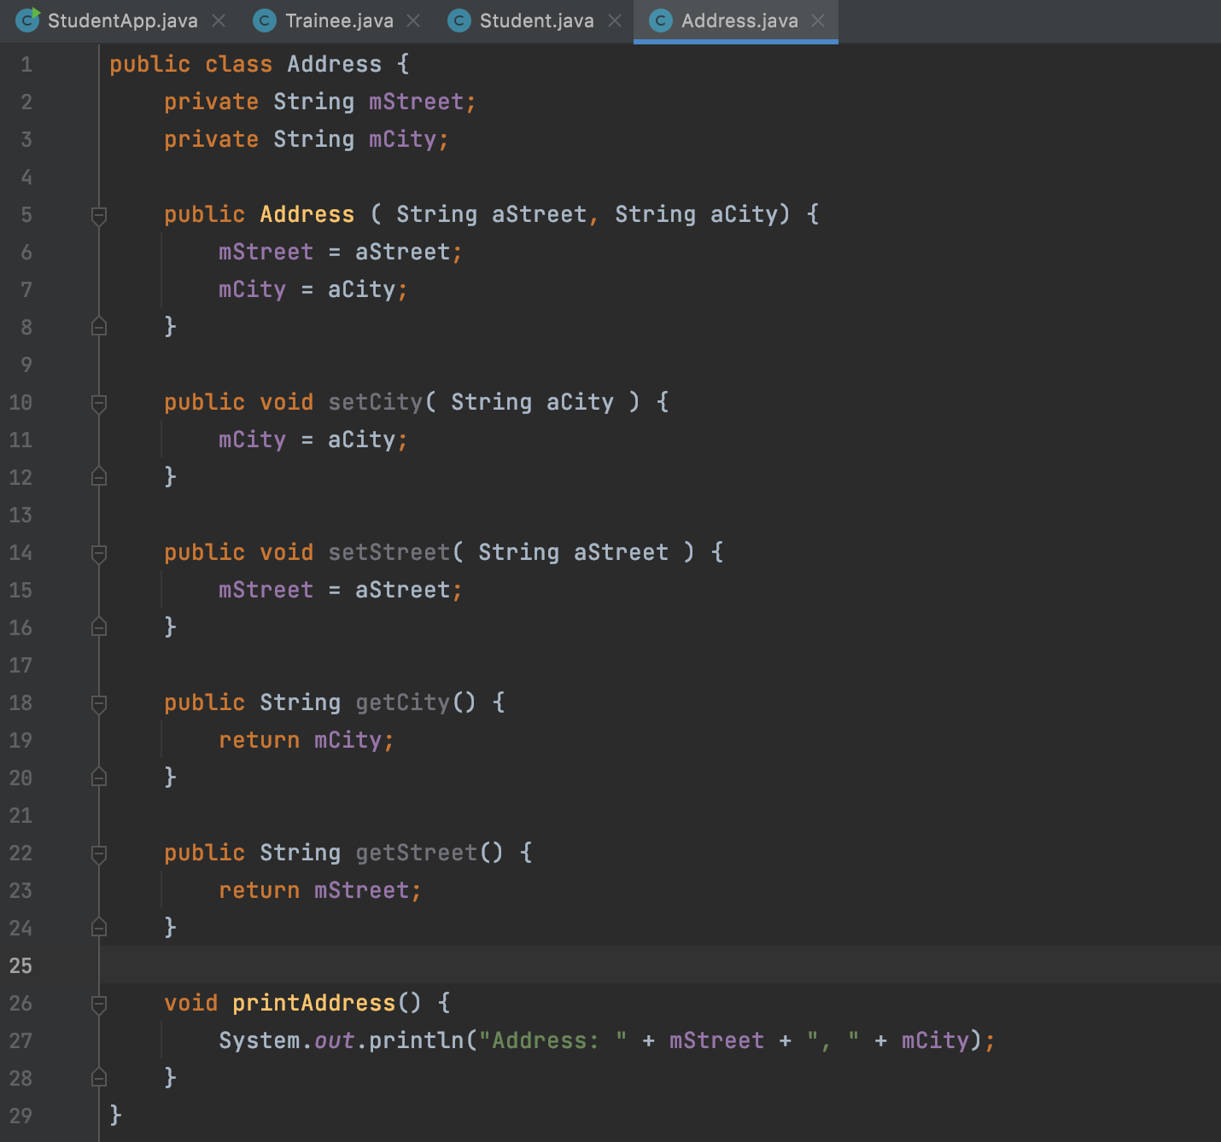

Extra constructor containing address parameter:

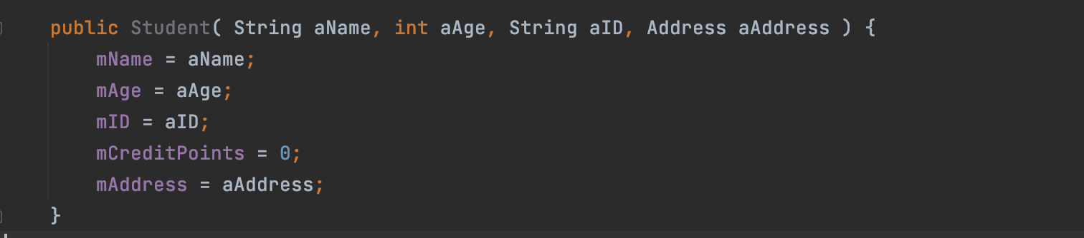

Creating students in the main program:

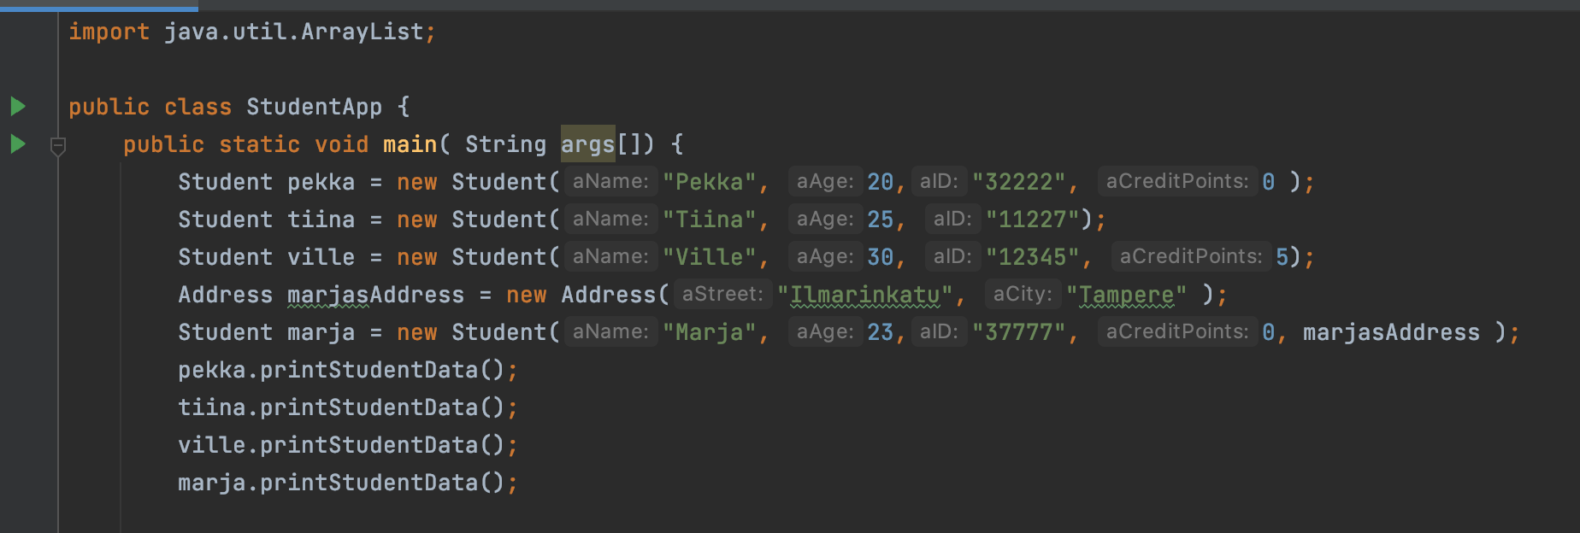

4.2 Trainee class

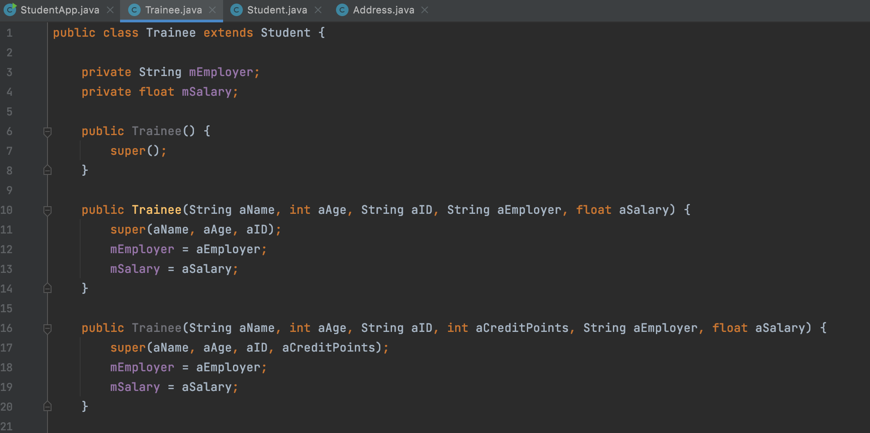

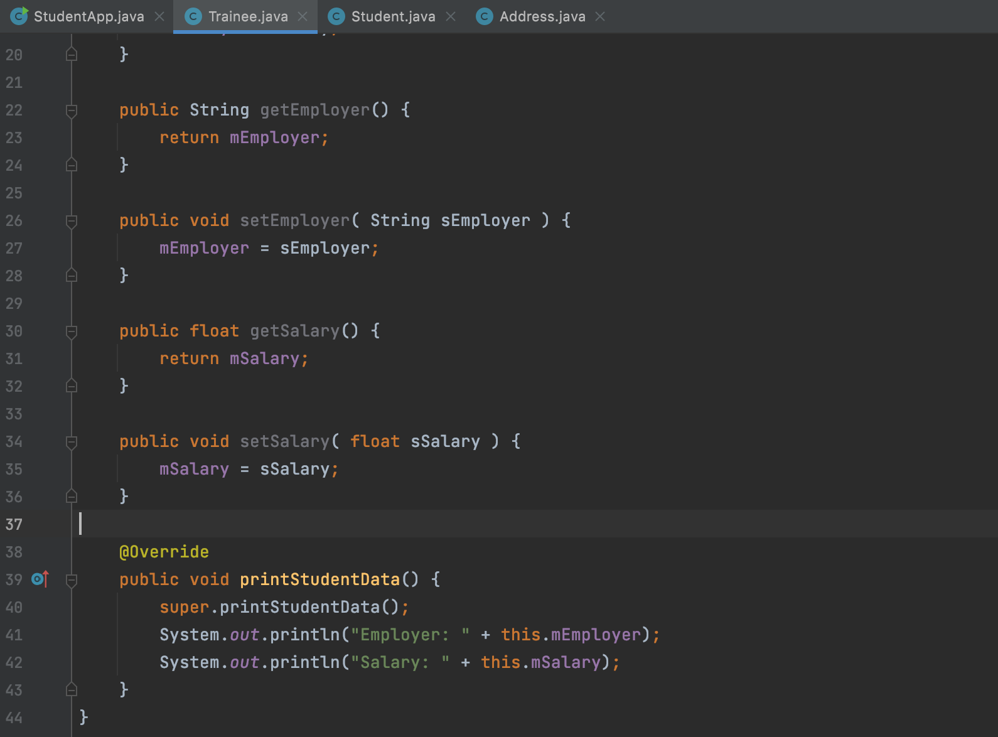

4.3 Array of students

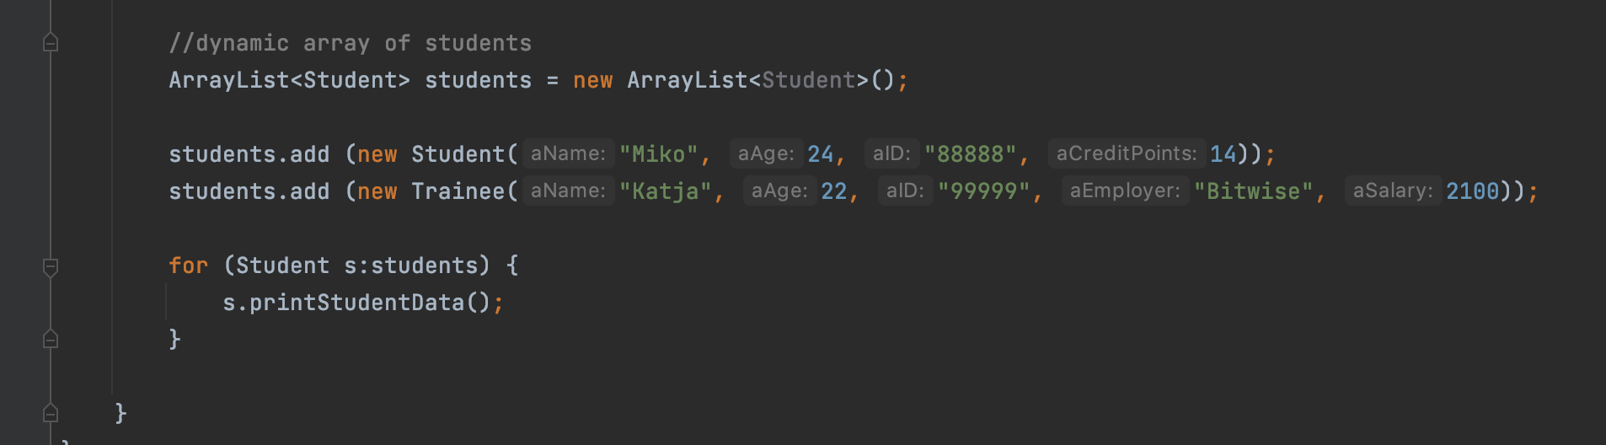

# Week exercises

## App GUI with 2 screens

Creating the second activity

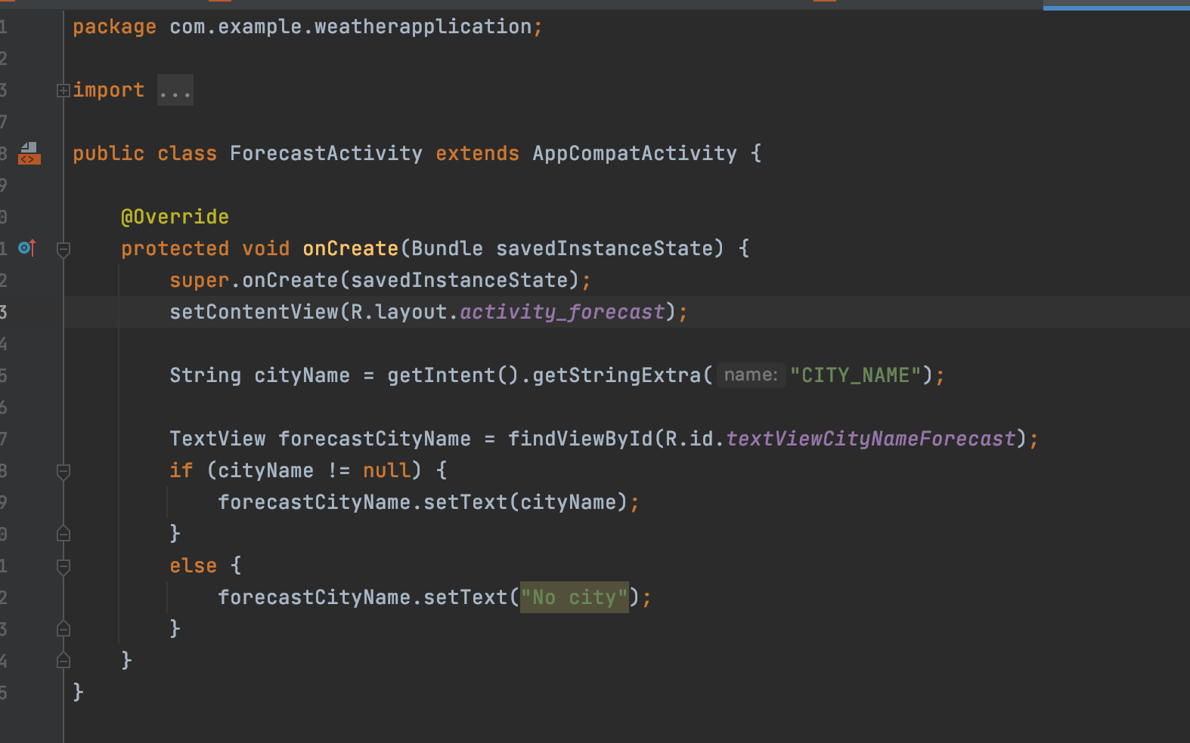

Creating the intent

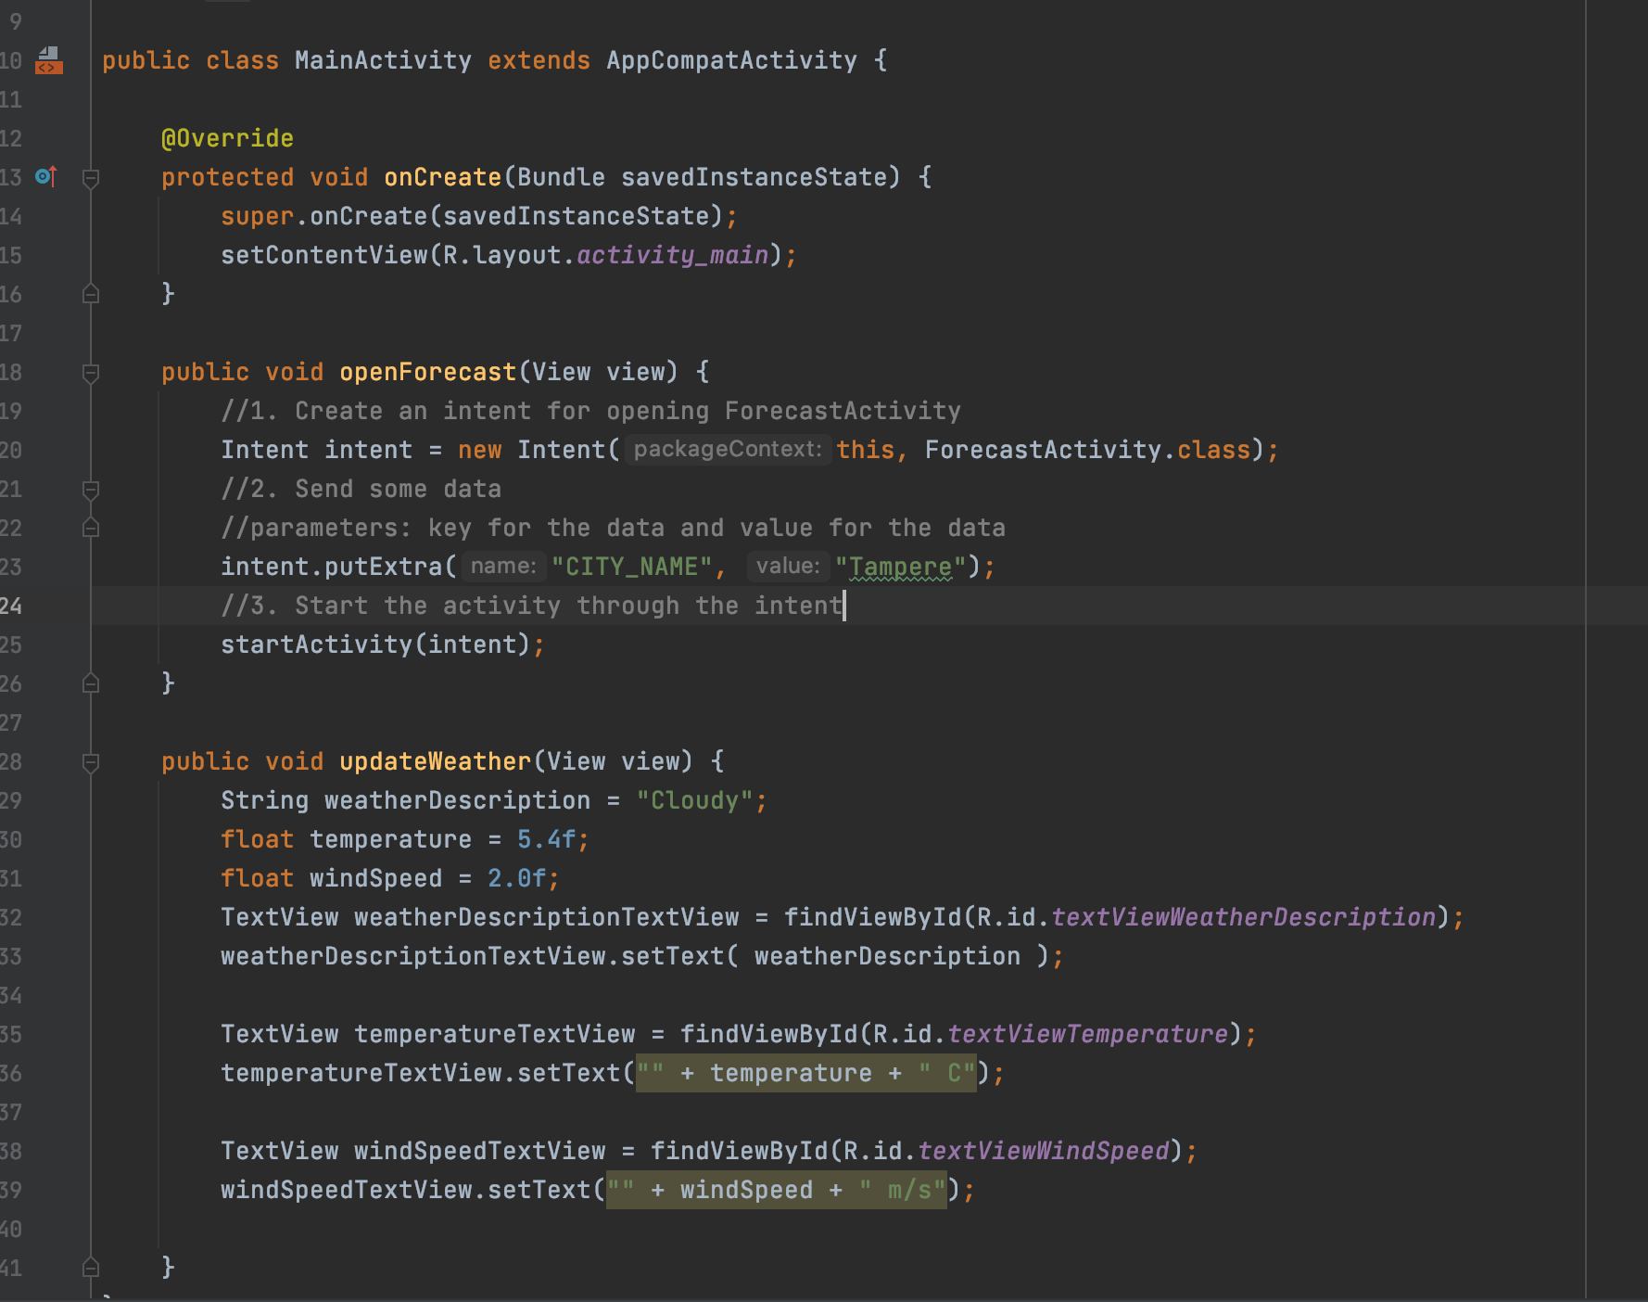

Application screens (localized Russian version):

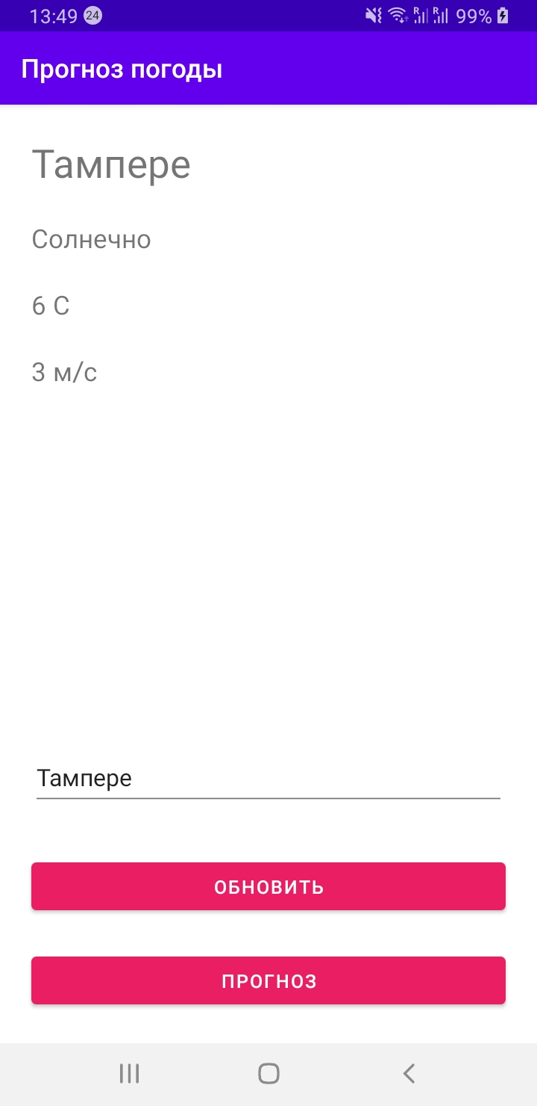

After update:

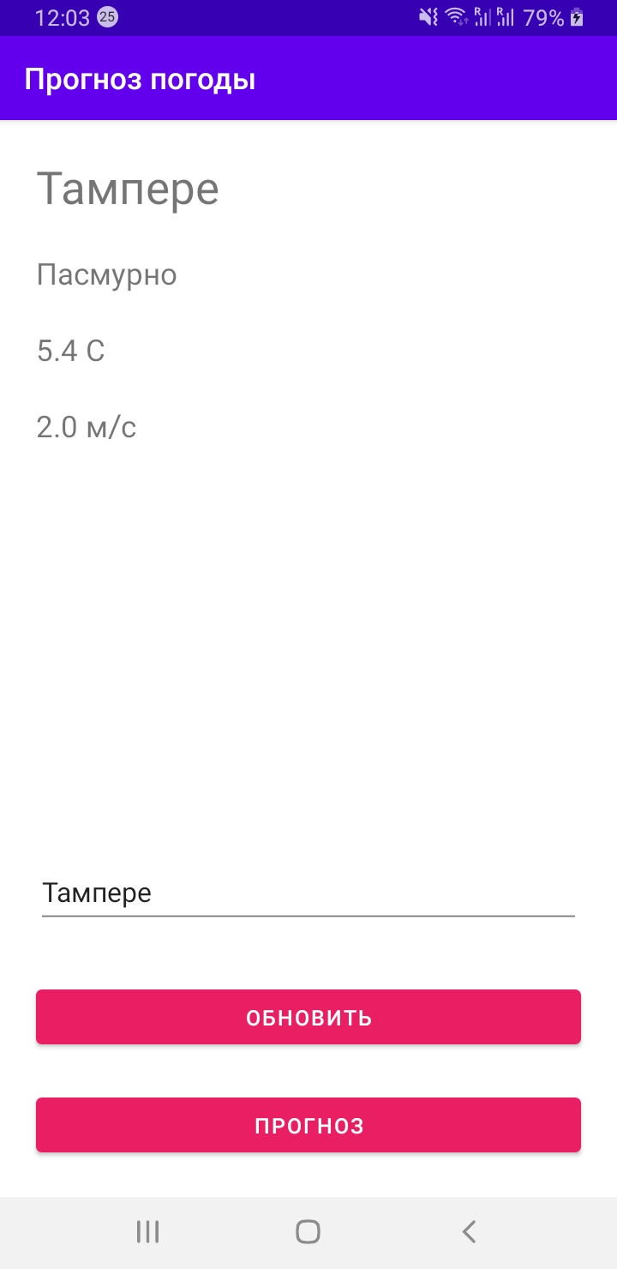

Second activity:

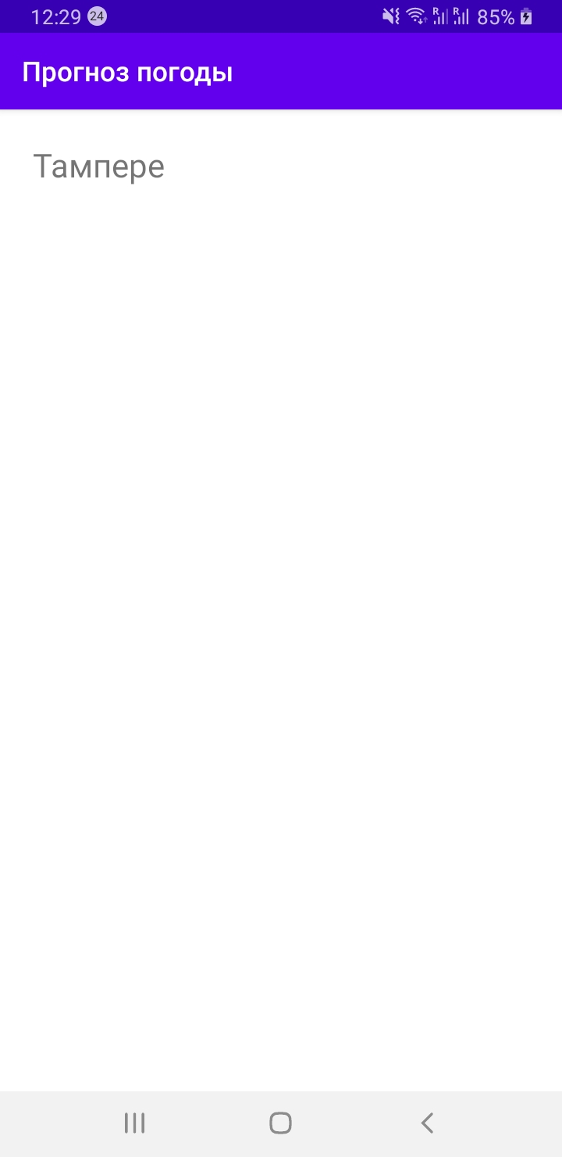

## Written exercises

Activity is a screen of an application (can be multiple activities in one application) which consists of XML and Java files. XML is for GUI layout (design), and Java is for logic.

An activity lifecycle is based on 7 methods: onCreate(), onStart(), onResume(), onPause(), onStop(), onRestart(), onDestroy(). Thus it can be created by onCreate() method and closed/finished by onDestroy() method.

Main activity is created when the application is launched (can be other activities which are created when the user switches to another view), and closed when the app is stopped or another activity is started.

Intent is a tool used to switch from one activity to another. It’s a message that triggers Activity. Intent is a call to activate something + data to send with the call. Data may contain key-value pairs for additional information to be delivered to the component handling the intent.

# Week exercises

## Fetching HTTP data and parsing JSON

To get REST data from a HTTP server, we’ll need to use an API in the Internet with a specific address. Usually Fetch or Axios methods are used to get data. For Android the most used library is Volley. Thus in Android we create RequestQueue, pass it Request objects. Once we add the request it moves through the pipeline, gets serviced, and has its raw response parsed and delivered. As a callback function we get result – either successful or failed.

When JSON object is received, we just parse data from the object by using getJSONObject and getJSONArray methods. We use “try … catch” statement to handle it just to make sure it is a valid JSON object.

## Fetching HTTP data and parsing JSON

As an application I used previously developed weather app and weather API with this address: https://api.openweathermap.org/data/2.5/weather?q=tampere&units=metric&appid=5bb5570e03fef03fc9963343649ae985

We add RequestQueue:

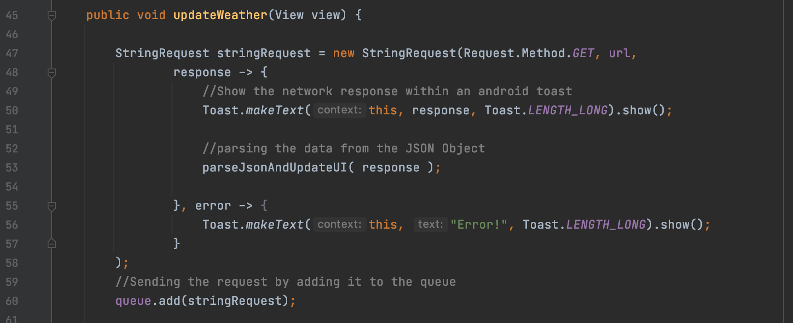

Then we parse data from JSON object:

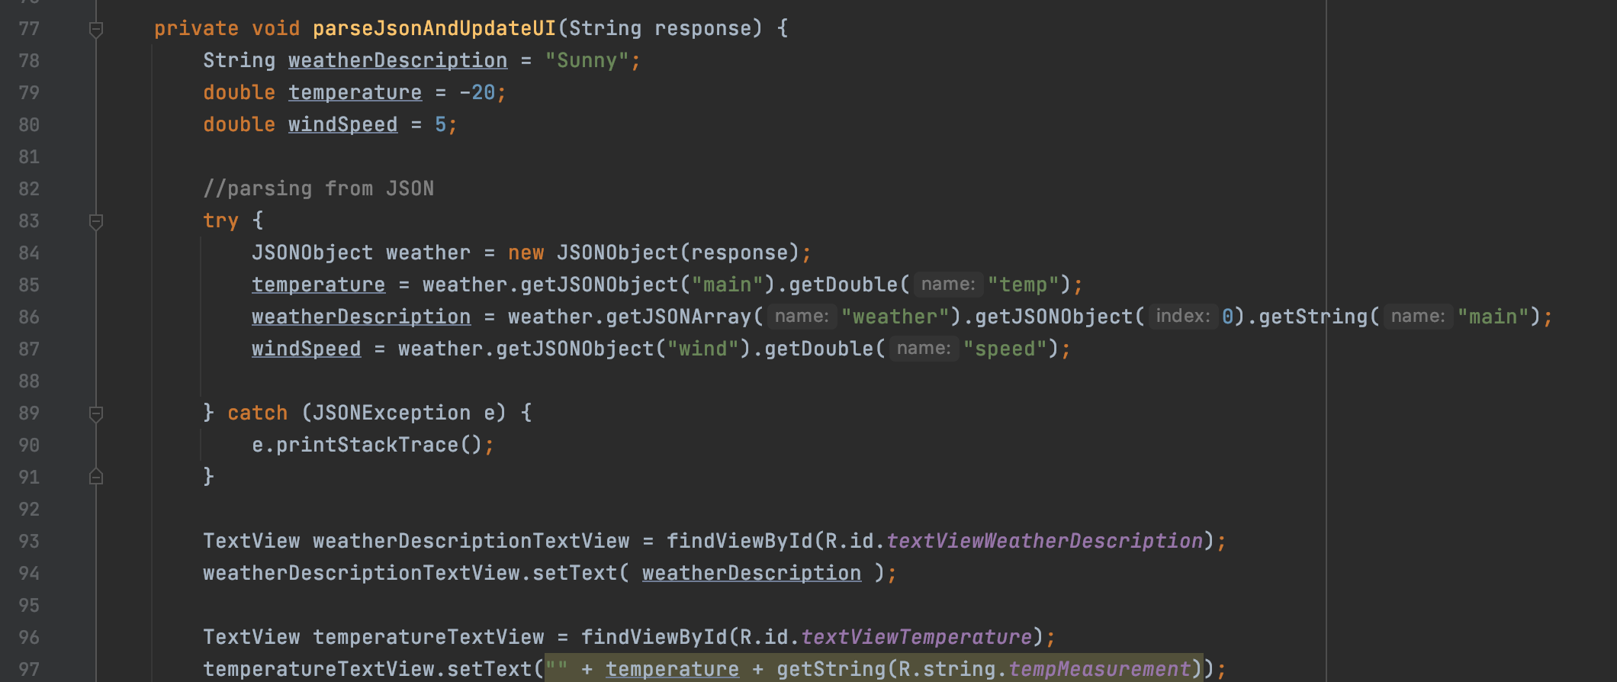

Here are screenshots of the app:

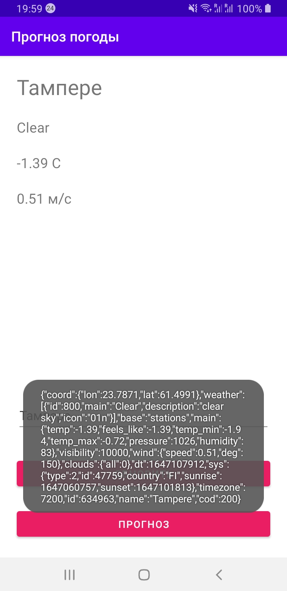

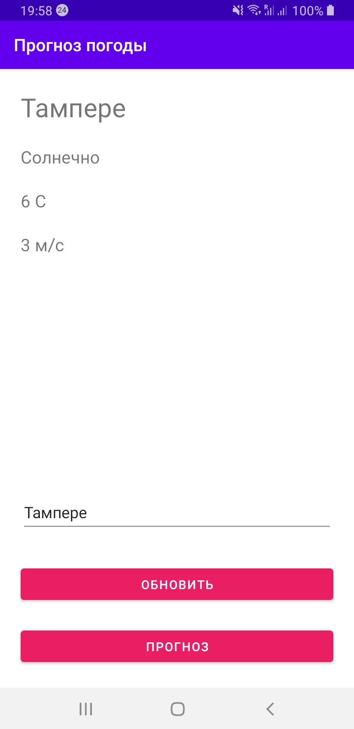

# Week exercises

## Synchronous device API Example – Camera HW and “torch app”

Flashlight App screenshots

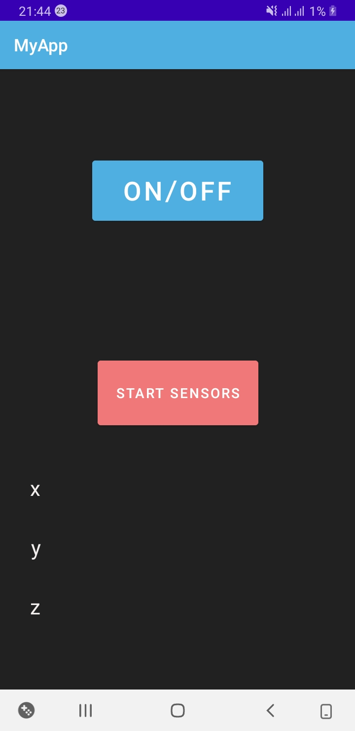

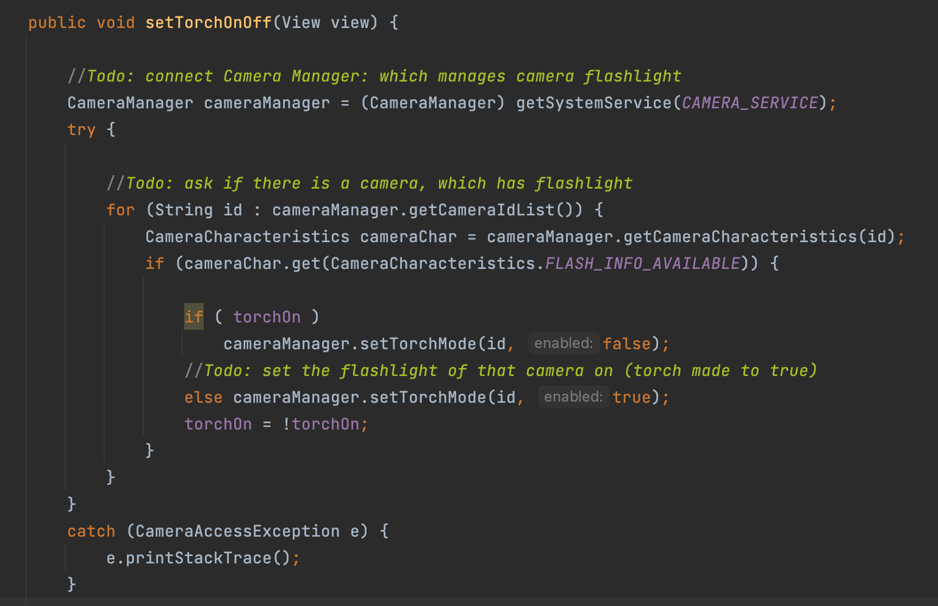

In the emulator we can test the app using logcat in Android Studio.

## Asynchronous API call example (listener) – Sensor API and “Level App”

App screenshots

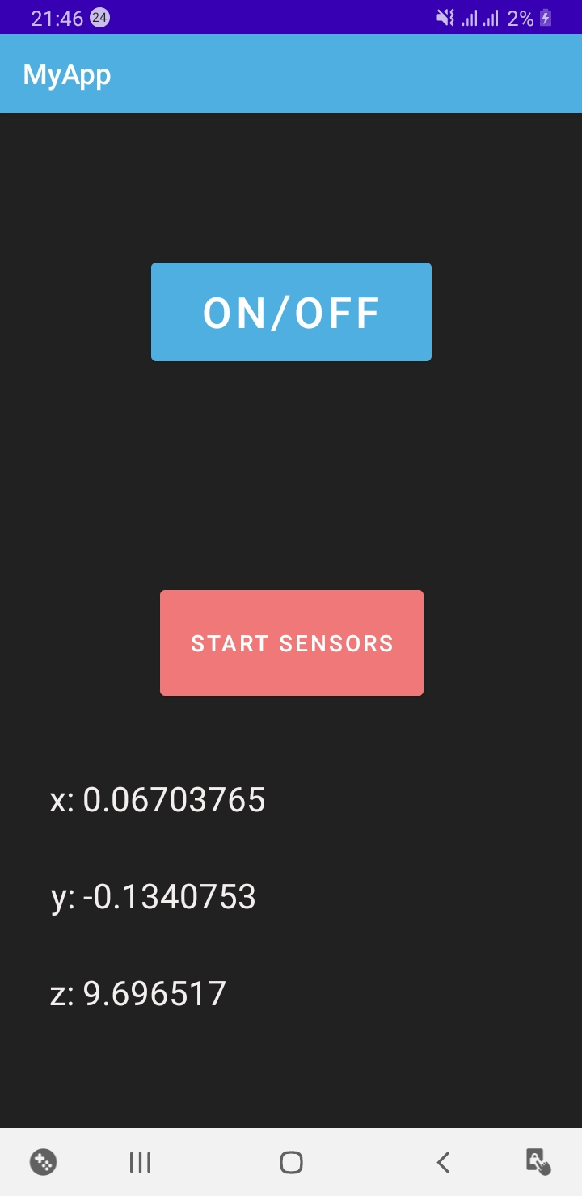

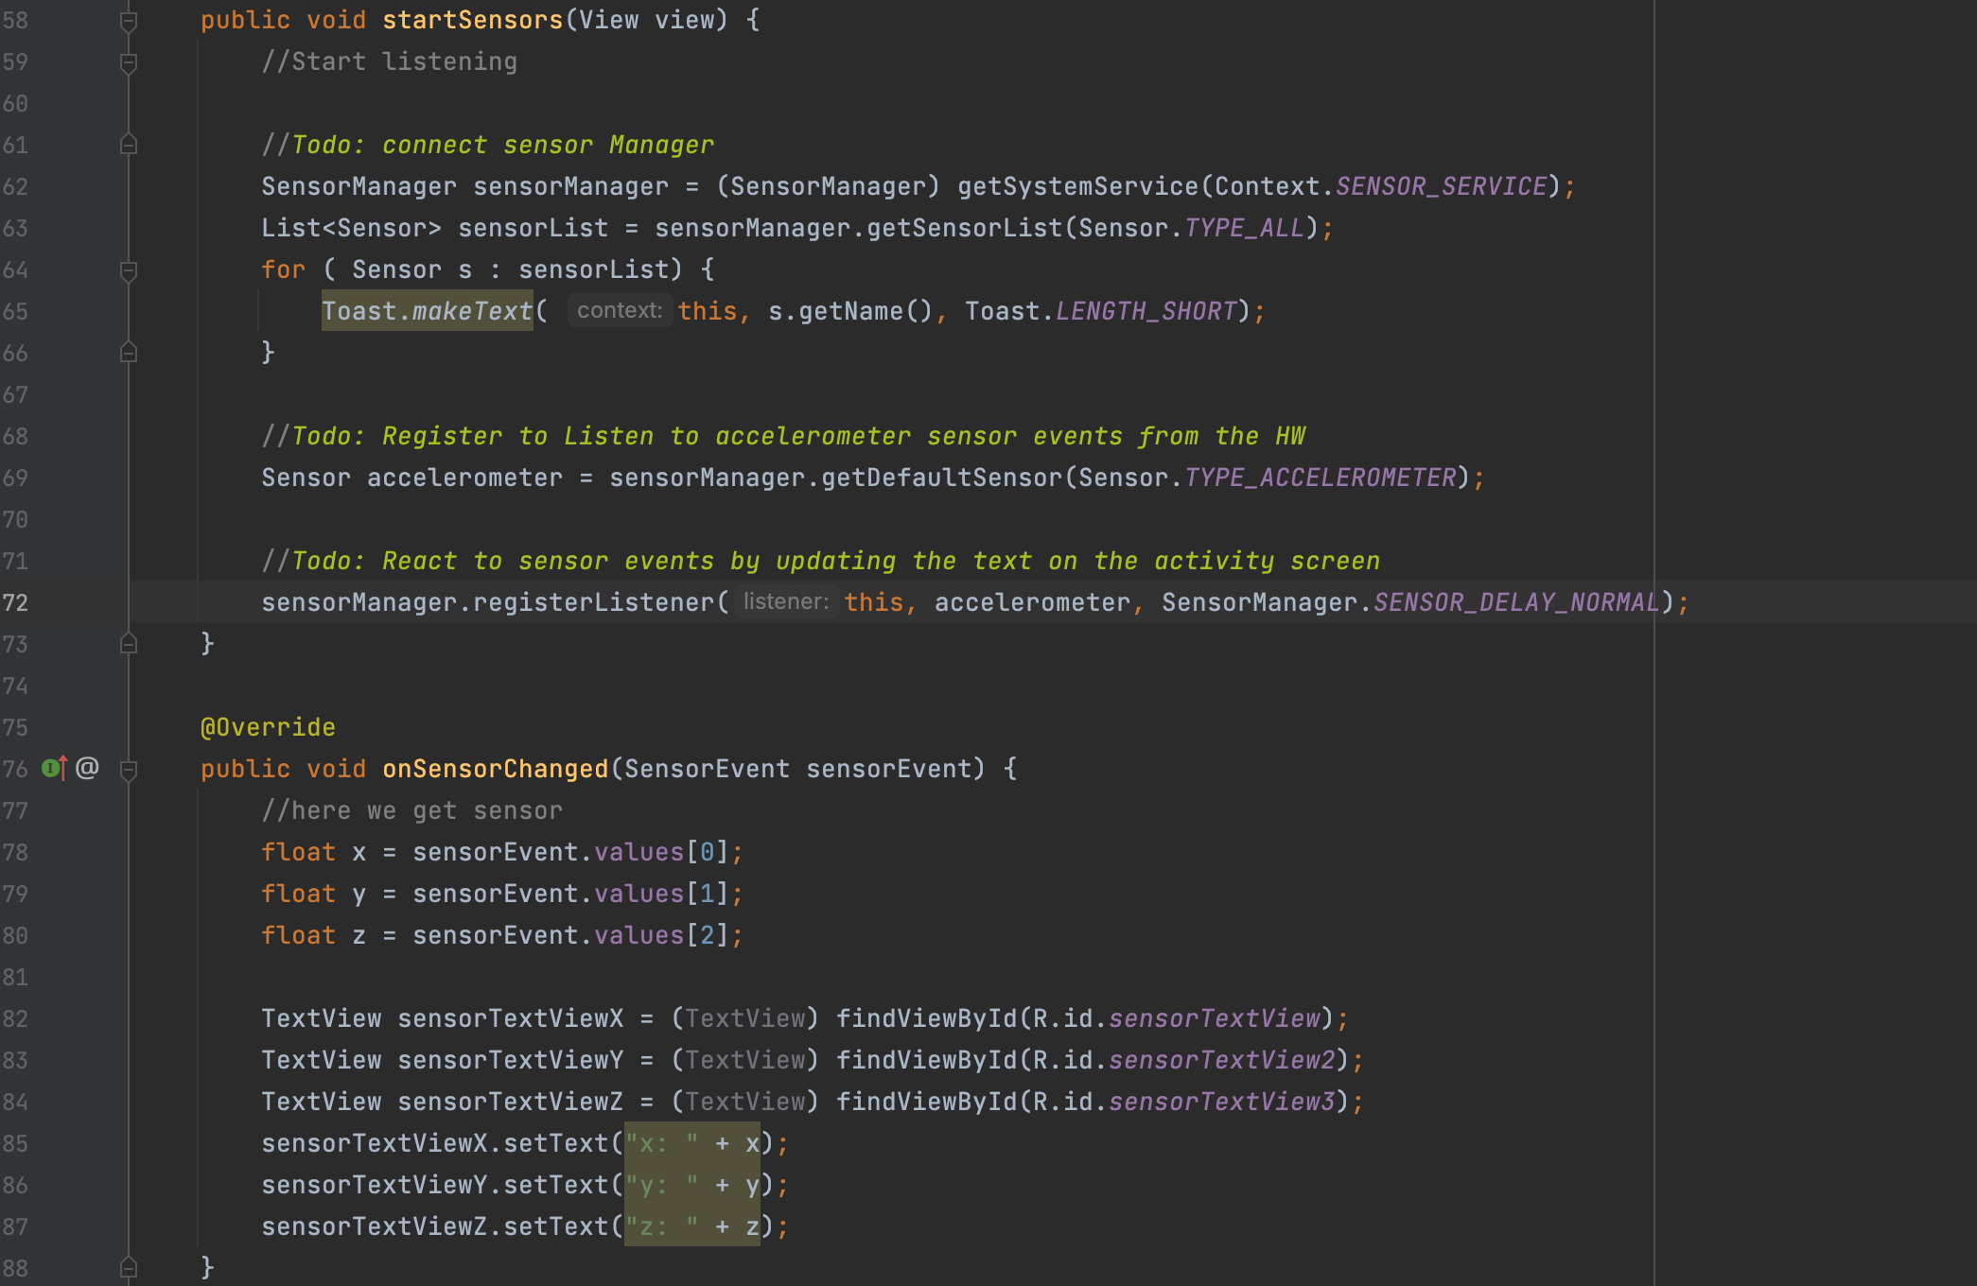

# Week exercises

## Android app permission workflow

Flashlight App screenshots

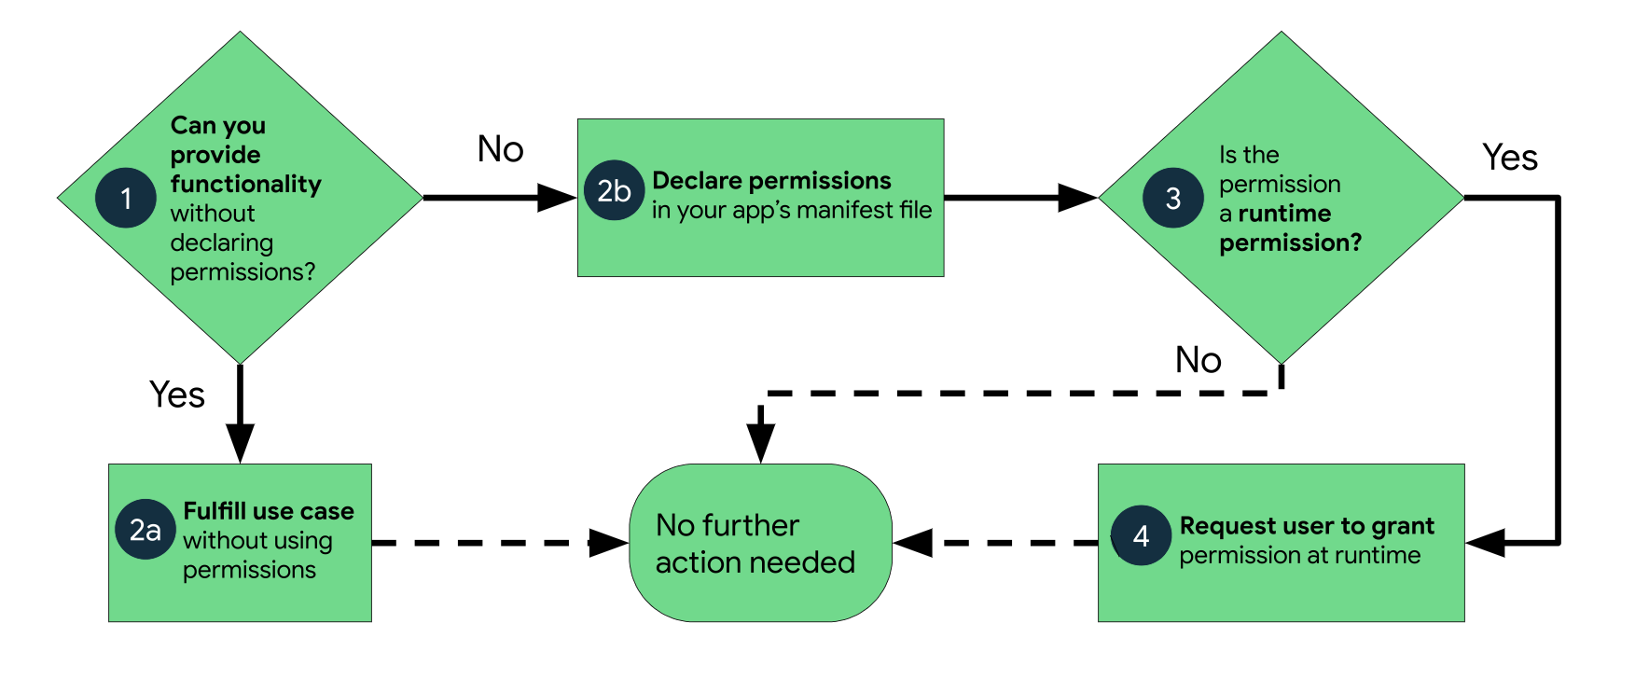

If an app doesn’t use any permissions, then nothing is needed. But an app uses permissions, then they are declared in the app’s manifest regardless of the type of permission (at this step these are install-time permissions). When one declares install-time permissions in your app, the system automatically grants the app the permissions when the user installs the app. If a runtime (dangerous) permission is needed then the app needs to request this permission additionally in the app from the user before the app can access the restricted data or perform restricted actions. Many runtime permissions access private user data, a special type of restricted data that includes potentially sensitive information. Examples of private user data include location and contact information.

Example from the app using GPS location data:

Install-time permissions in the manifest file:



Requesting a runtime permission and checking if it was granted or not (in MainActivity.java file)

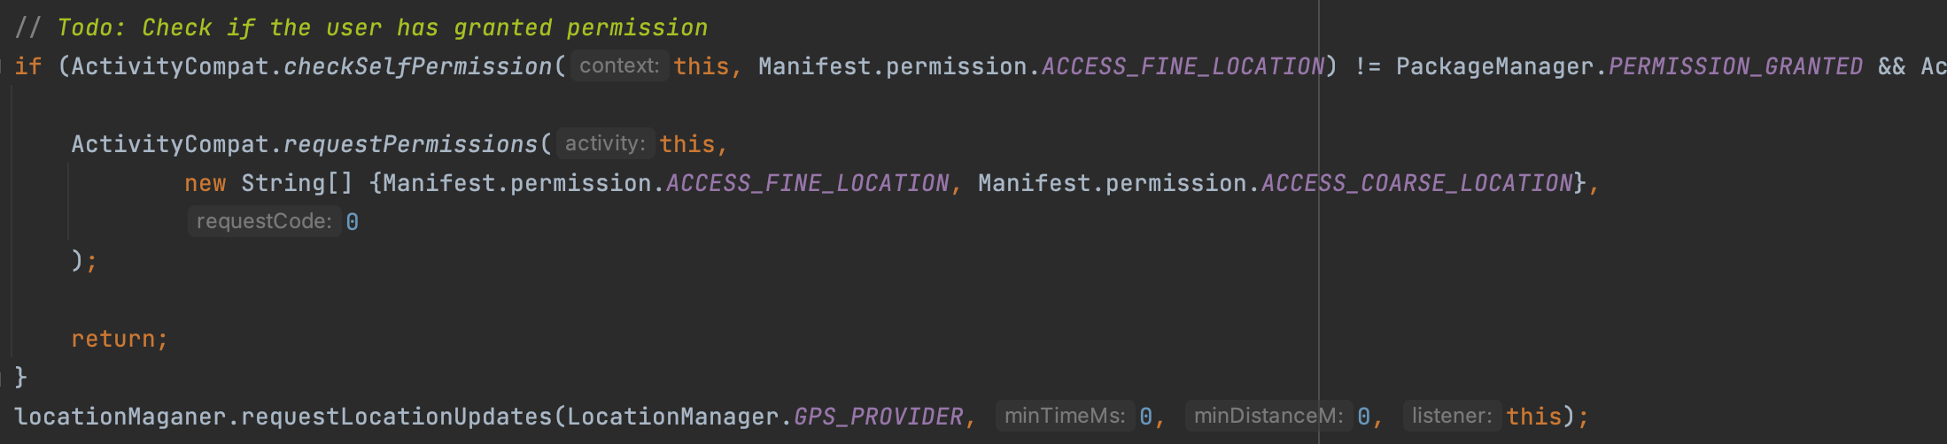

## Android app permission workflow

GPS feature:

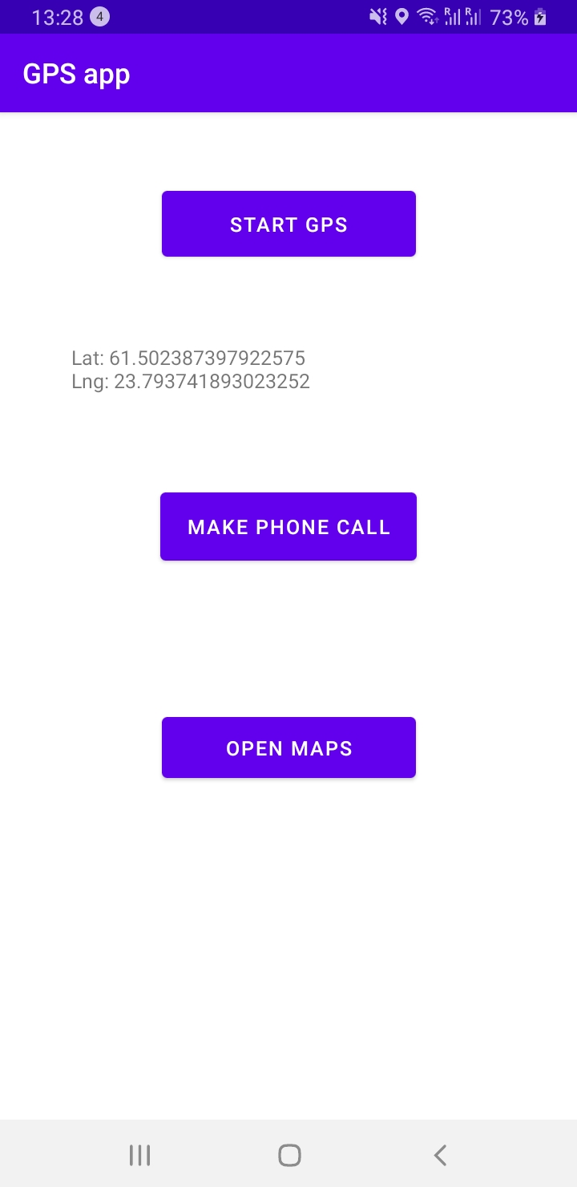

Calling feature after pushing the button:

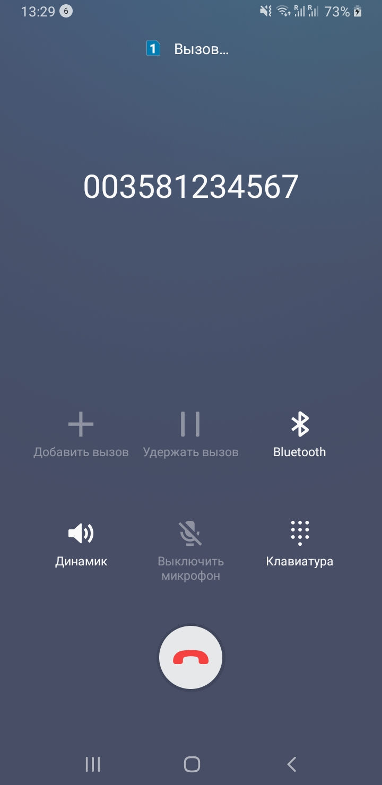

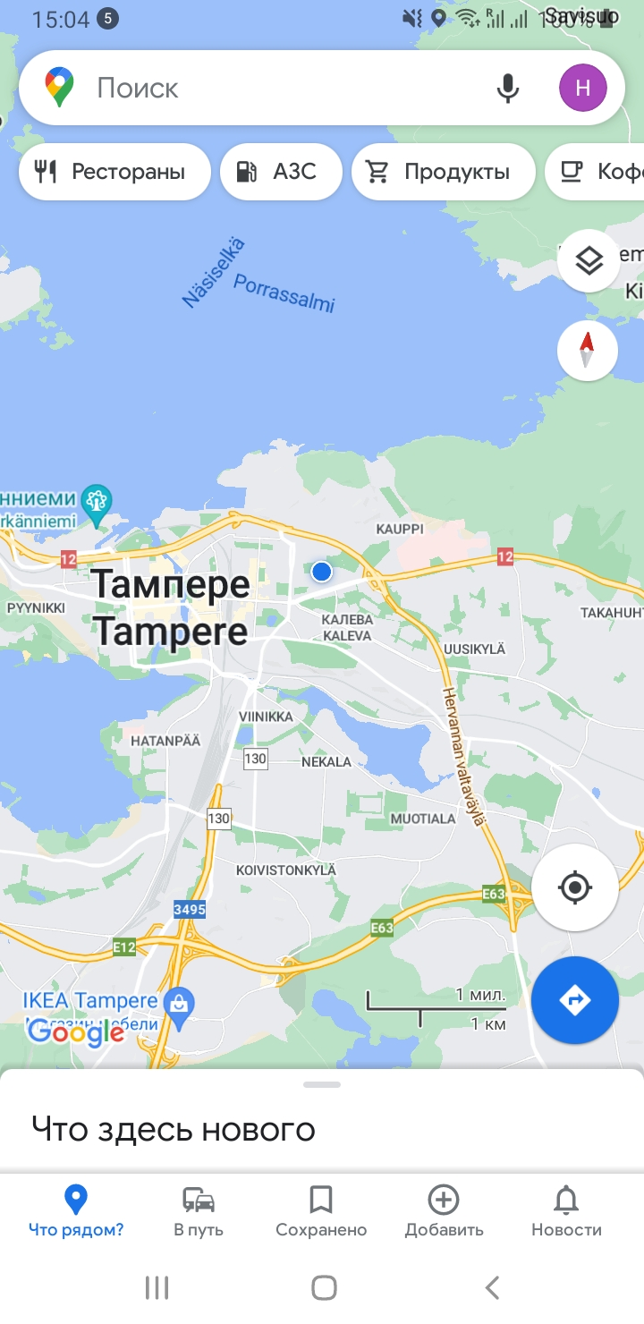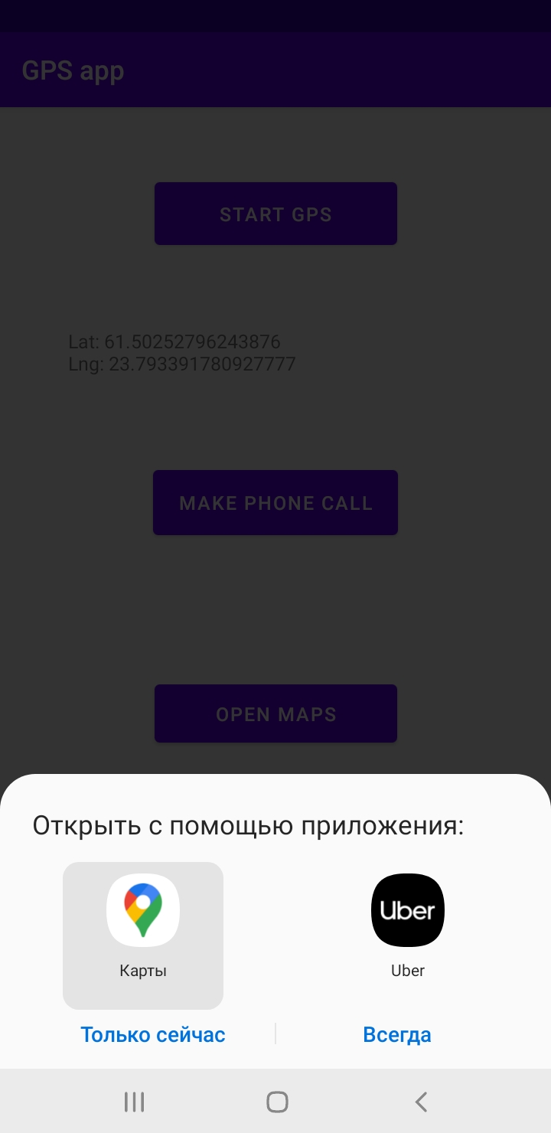Maps feature using GPS location data (asking which app to use and then another activity)

showMap method in MainActivity.java:

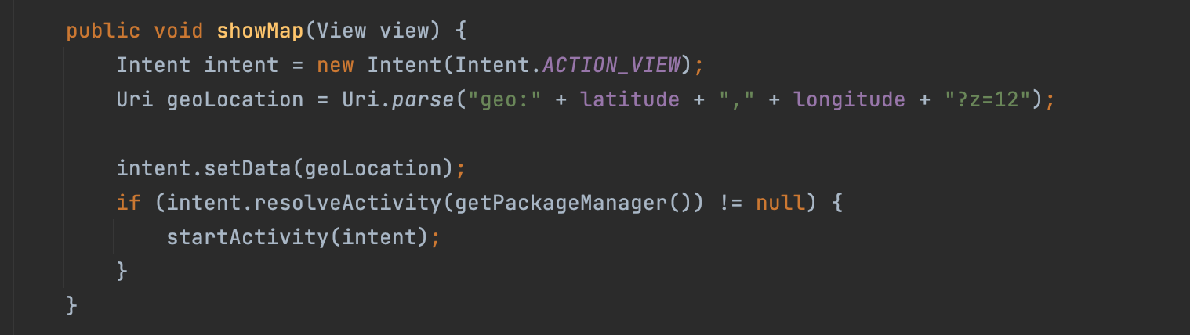

# Week exercises

## Written answers

Android Activity lifecycle states:

An activity lifecycle is based on 7 methods: onCreate(), onStart(), onResume(), onPause(), onStop(), onRestart(), onDestroy(). Thus it can be created by onCreate() method and closed/finished by onDestroy() method.

Main activity is created when the application is launched (can be other activities which are created when the user switches to another view), and closed when the app is stopped or another activity is started.

onPause() method is implemented when the activity is going to the background (still visible), onStop() is implemented when the activity is not visible anymore. If the the acitivy is back on the foreground, then onResume() and onStart() methods are impelemented. These methods are callbacks.

Activity data bundle means all data that is stored during the activity lifecycle. For example, if an activity is destroyed at some point, data can be saved and restored later.

If we change the device orientation, then the activity is stopped, destroyed and recreated again, so data can be lost if it is not saved before destroying the activity.

## Code

Implementation of saving/restoring local activity data whenever the device is turned and activity is destroyed and recreated. Here is the code:

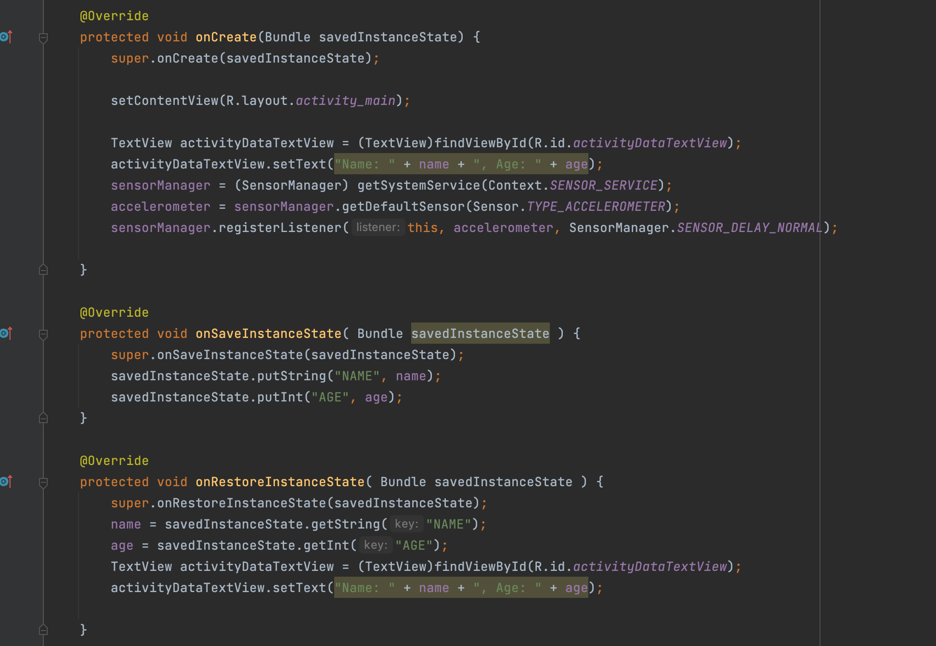

Initial screen:

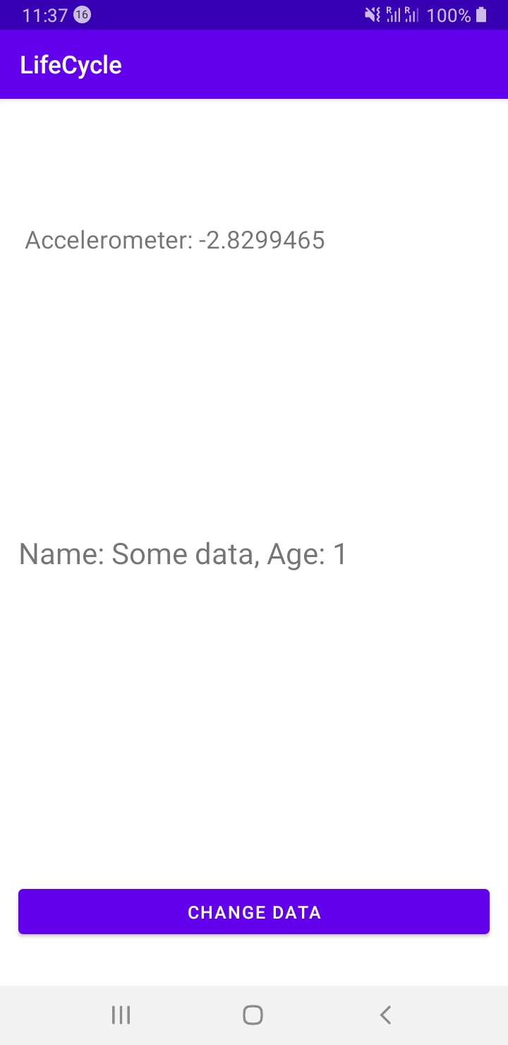

After pushing the button:

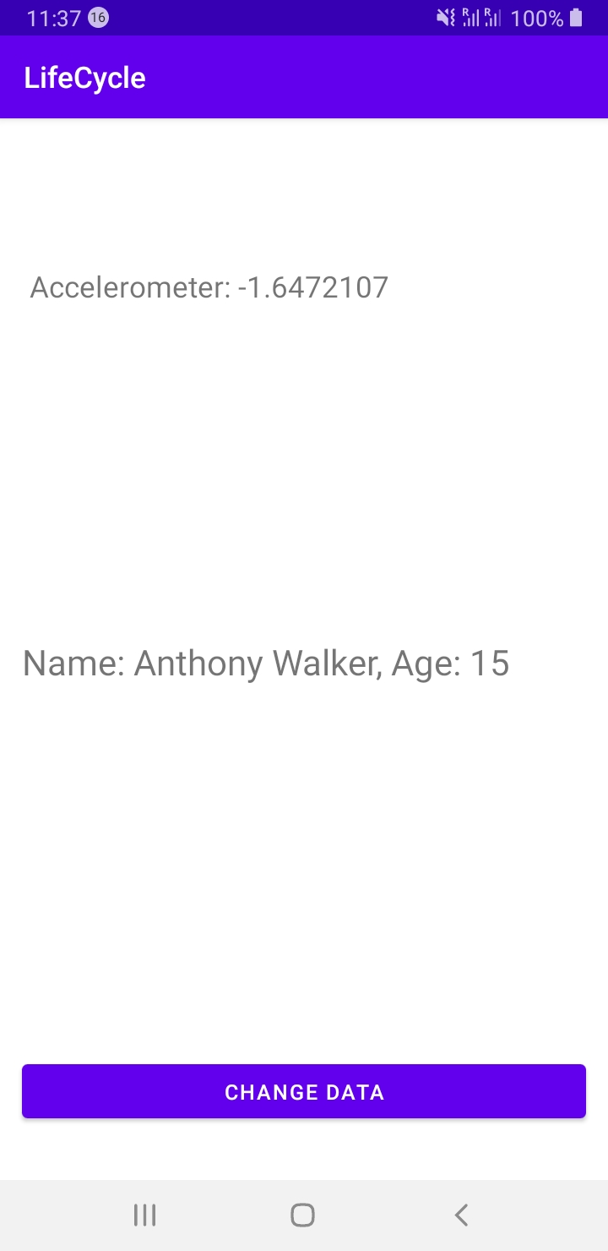

After changing portrait orientation to landscape:

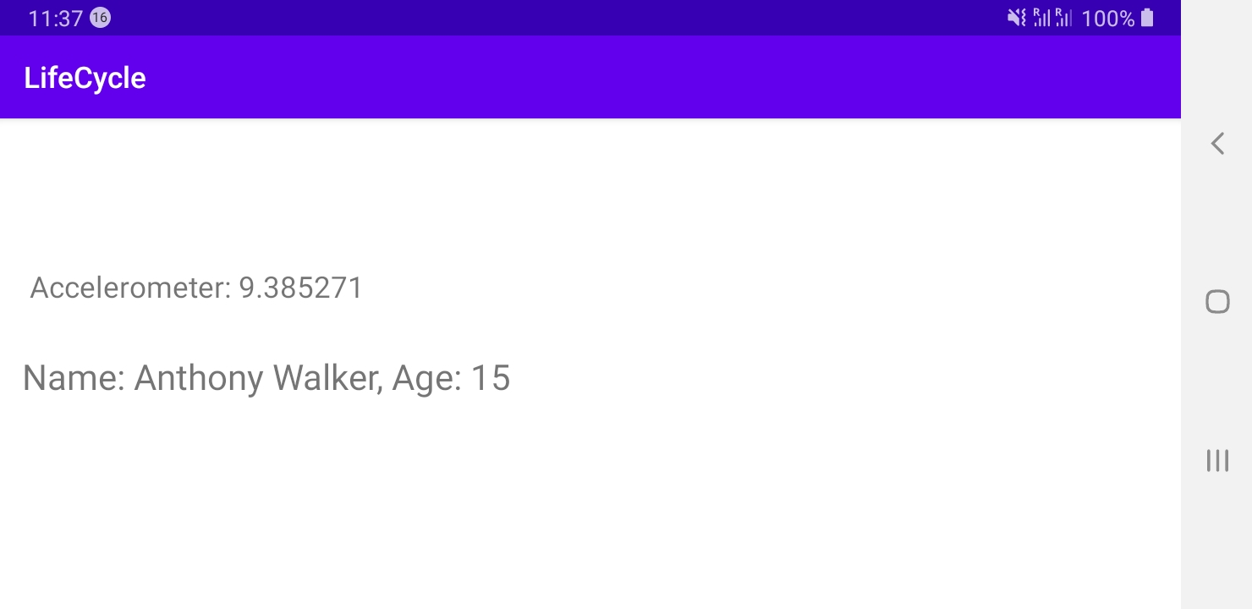

Implementation of unregistering and registering to sensors as a listener:

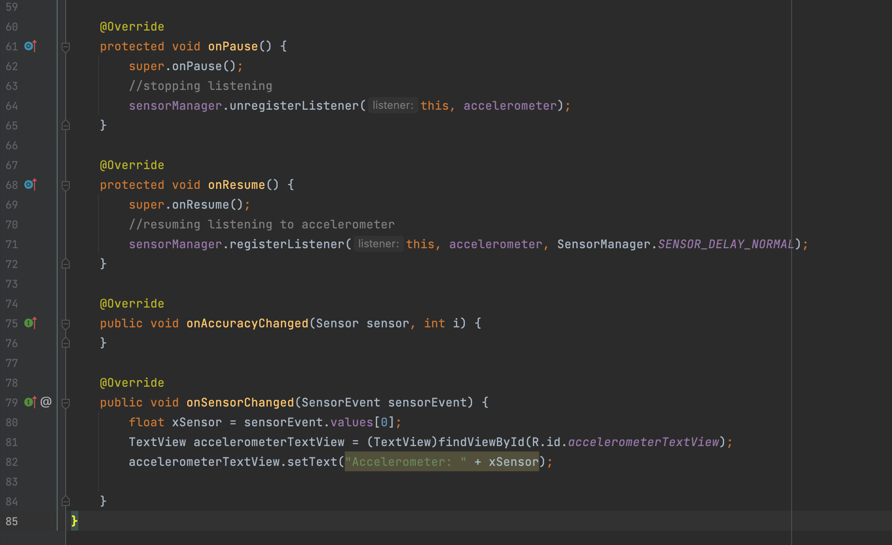

**Final project**

Description of the project: the Android application consists of 2 activities (main screen and Currency exchange rates activity) + using GPS sensor with opportunity to open one more activity – showing the current location of the user in the Google Maps application. Currency exchange rates activity will use REST API to parse rates as of current date.

Current version: 1.0

Programming language: Java/XML

Github link: https://github.com/Dialex2006/AndroidAppDevelopment

The main screen activity looks like this:

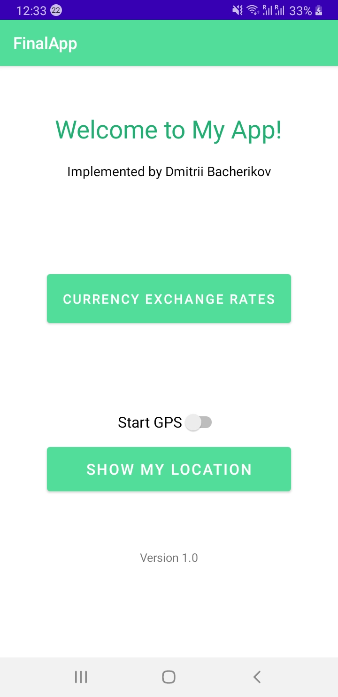

On this page the user has 2 opportunities:

1. Start another activity (Currency Exchange Rates), Intent is used:

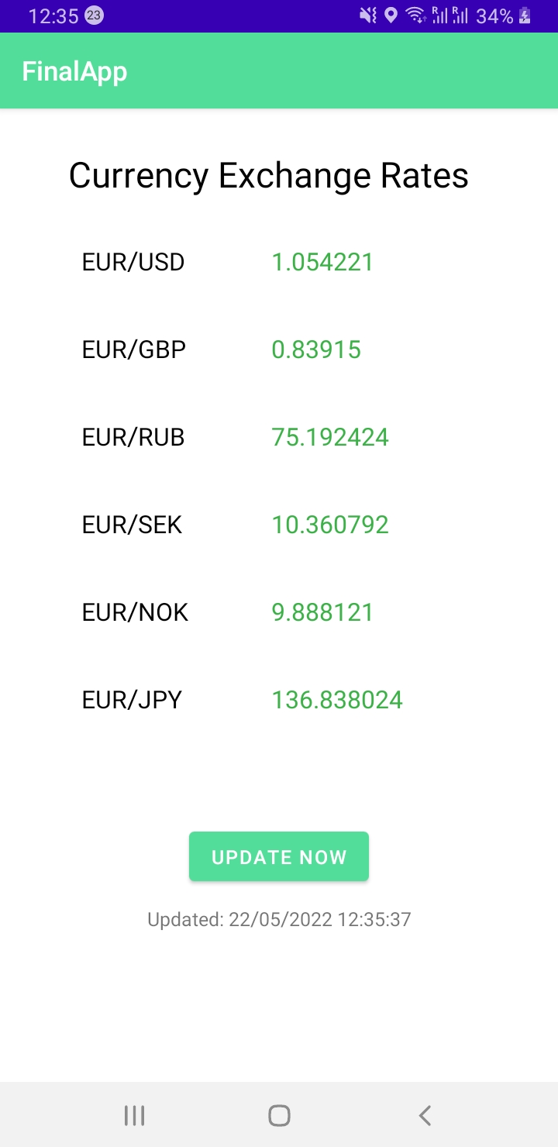

On this page the user has possibility to request update manually, data is parsed using REST API in JSON (URL: <https://api.exchangerate.host/latest>)

On this screen after clicking “Update now” button we can see that time of update has been changed:

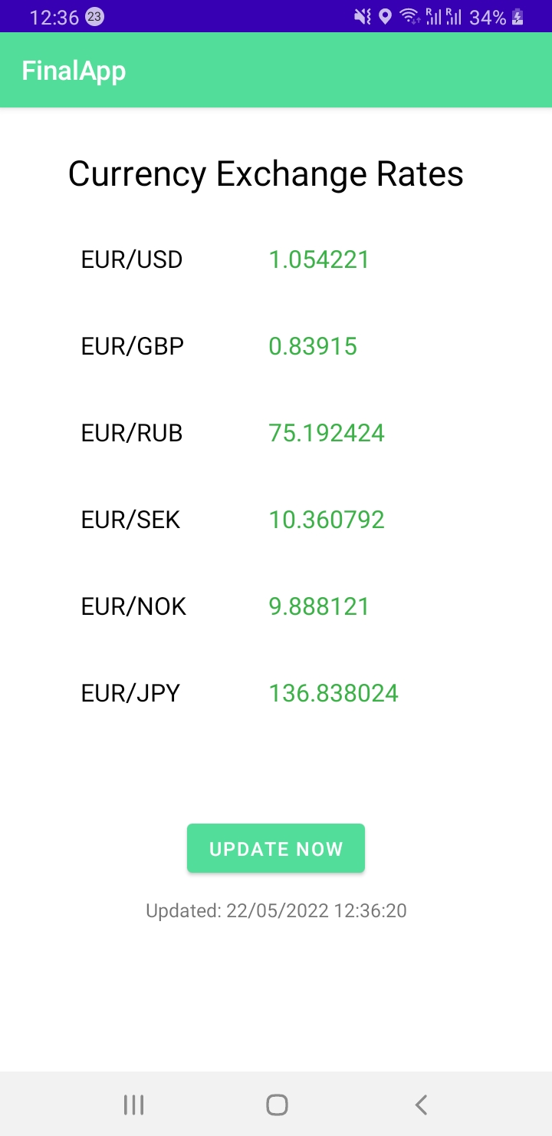

1. Show My Location

If the user wants to show one’s location, first one needs to turn on GPS switch “Start GPS” to start the sensor and to make sure the user granted required permission. If the switch is not turned on, then the app won’t allow to open Google Maps app.

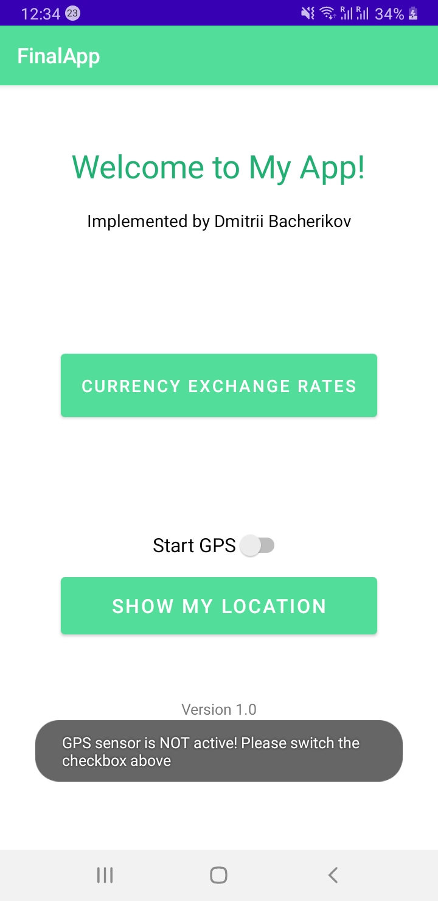

If the user turns on the switch, the app will ask for permission from the user because this permission is ‘dangerous’:

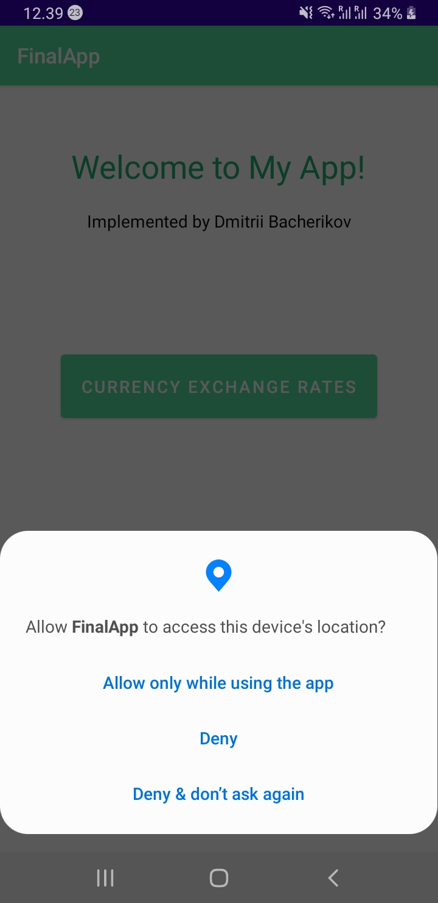

After the user allows to access the device’s location, the user can click the button “Show My Location”, but here 2 options are possible:

If GPS hasn’t defined location yet, then it will show this message:

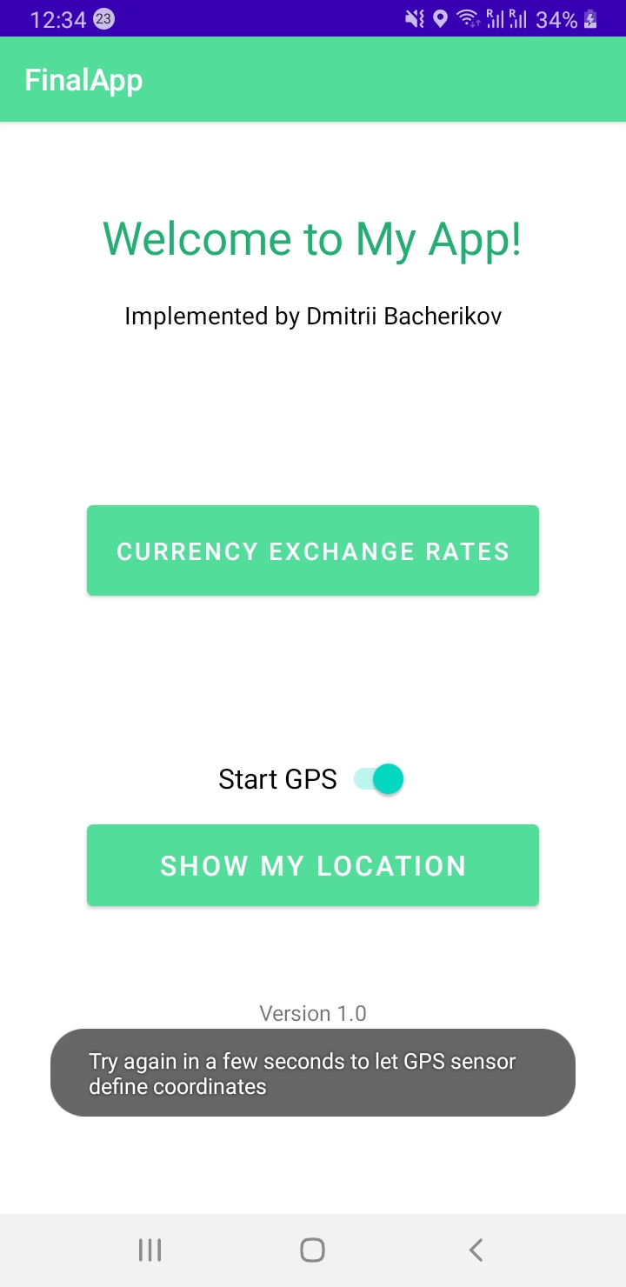

It means that the sensor needs a bit more time to define location or the device is located inside the building where GPS is not accessible. If the sensor has defined coordinates, then the app will send location coordinates and show location in the Google Maps app (Intent is used here):

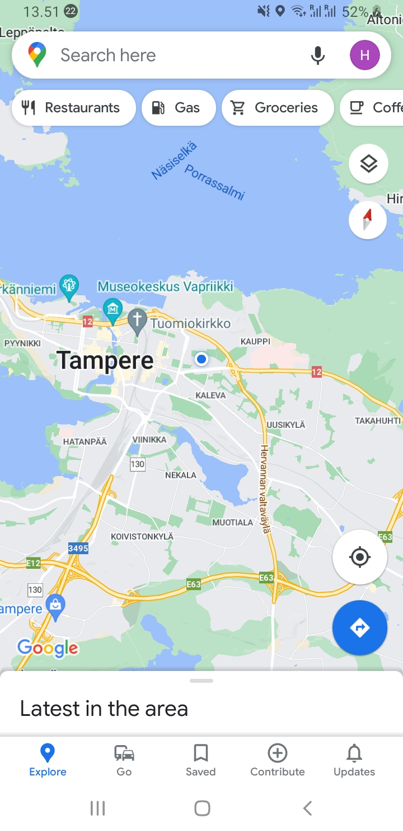

In my application opportunity of changing orientation (e.g. from portrait to landscape) is taken into account. In this case the user can scroll the screen:

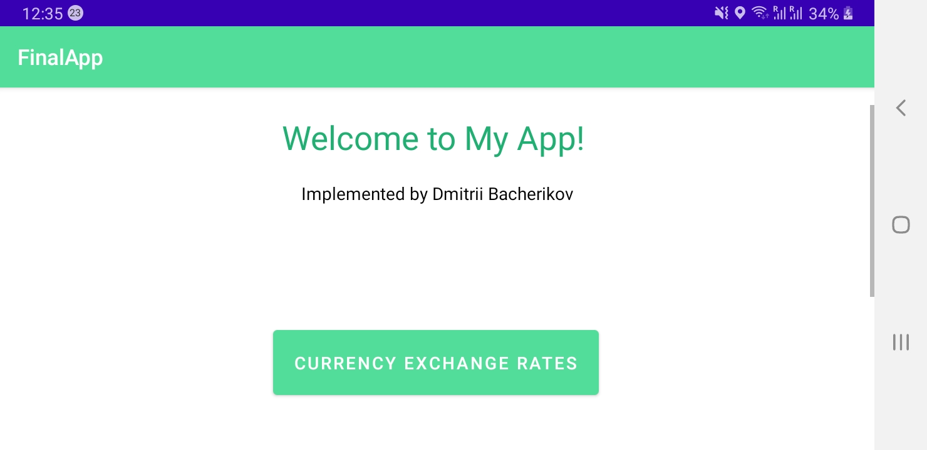

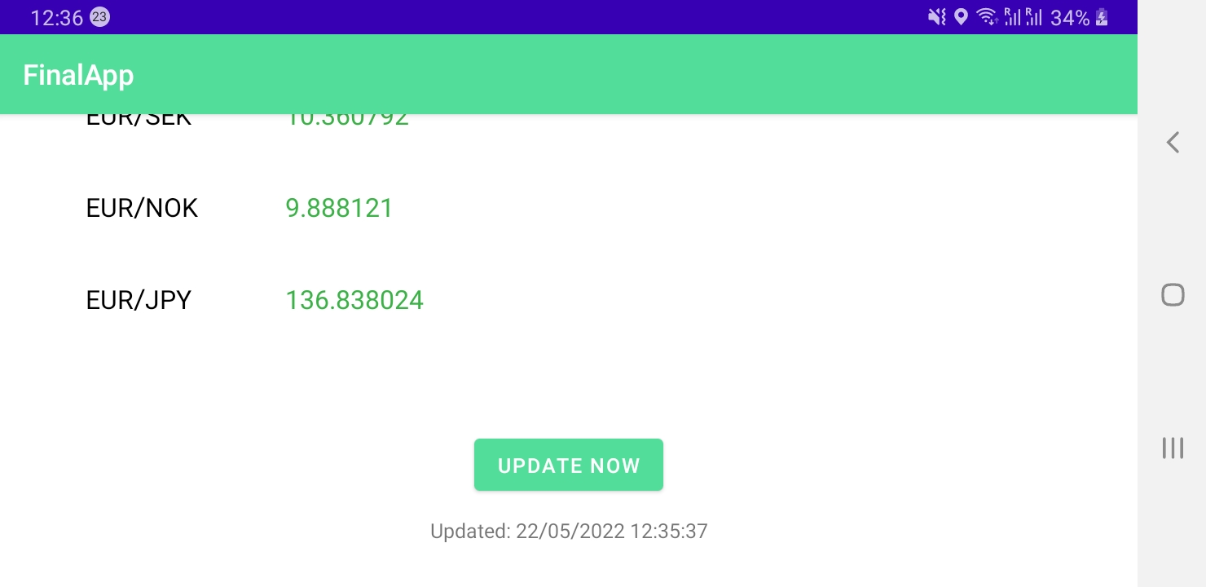

In case of changing orientation activities are stopped, destroyed and re-created, therefore **onCreate(), onResume(), onSaveInstanceState(), onRestoreInstanceState()** are overridden to restore our data.

In version 1.0 all strings, colors and themes use resource files instead of hard coding, which is the right way make the app. Besides the English version (by default) there is the Finnish localization using Translations Editor:

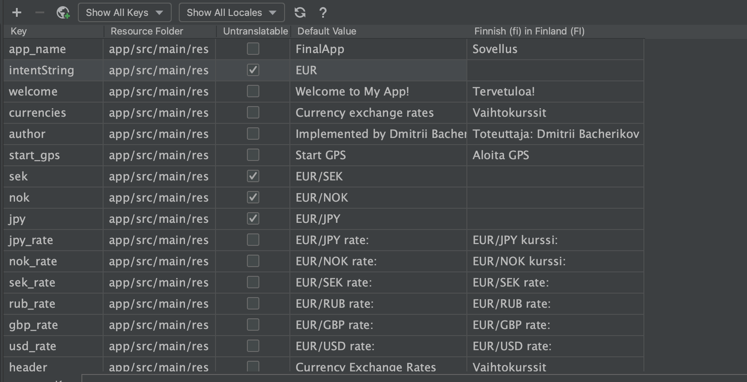

Sources used with exercises

1. <https://stackoverflow.com/questions/54273412/failed-to-install-the-following-android-sdk-packages-as-some-licences-have-not>

2. <https://stackoverflow.com/questions/16596877/android-studio-doesnt-see-device>

3. <https://developer.android.com/guide/components/activities/activity-lifecycle>

4. <https://java-programming.mooc.fi>

5. <https://google.github.io/volley/>

6. <https://api.openweathermap.org>

7. <https://developer.android.com/reference/android/hardware/camera2/CameraManager.TorchCallback>

8. <https://developer.android.com/guide/components/intents-common>

9. <https://stackoverflow.com/questions/14274815/calling-maps-intent-with-geolocation-is-it-possible-to-have-a-pushpin-on-it>

10. <https://developer.android.com/guide/topics/sensors/sensors_overview#java>

11. <https://www.section.io/engineering-education/understanding-and-implementing-the-android-lifecycle/>

12. <https://developer.android.com/reference/android/widget/Switch>

13. <https://developer.android.com/reference/android/widget/ScrollView>

14. <https://developer.android.com/topic/libraries/architecture/saving-states>

15. <https://stackoverflow.com/questions/151777/how-can-i-save-an-activity-state-using-the-save-instance-state>